Event 2000.10.16 – (2000-290)

Particle event: To(Ep>10 MeV) – 16d08^{h}
Tmax₁(Ep>10 MeV) – 16d11^{h}, Jmax₁(Ep>10 MeV) – 3.5/cm².s.sr
Tmax₂(Ep>10 MeV) – 16d17^{h}, Jmax₂(Ep>10 MeV) – 9.8/cm².s.sr *)
Duration of the event – 4 days
Energy of the SCR and 0.1 GCR fluxes balance – Eb(max₁) = 310 MeV
– Eb(max₂) = 140 MeV
*) The data from IMP-8

Sources: □ solar flare 16d06^{h}40^{m}, M2.5/ -, N05W90, АR9182
Main X-ray burst 1-8 Ǻ onset – 16d06^{h}40^{m}, max – 16d07^{h}28^{m}, Ф = 0.16 J/m²
CME: 16d07^{h}27^{m}, V = 1336 km/s, Δφ = 360º, dA = 270º

Particle fluxes and associated phenomena
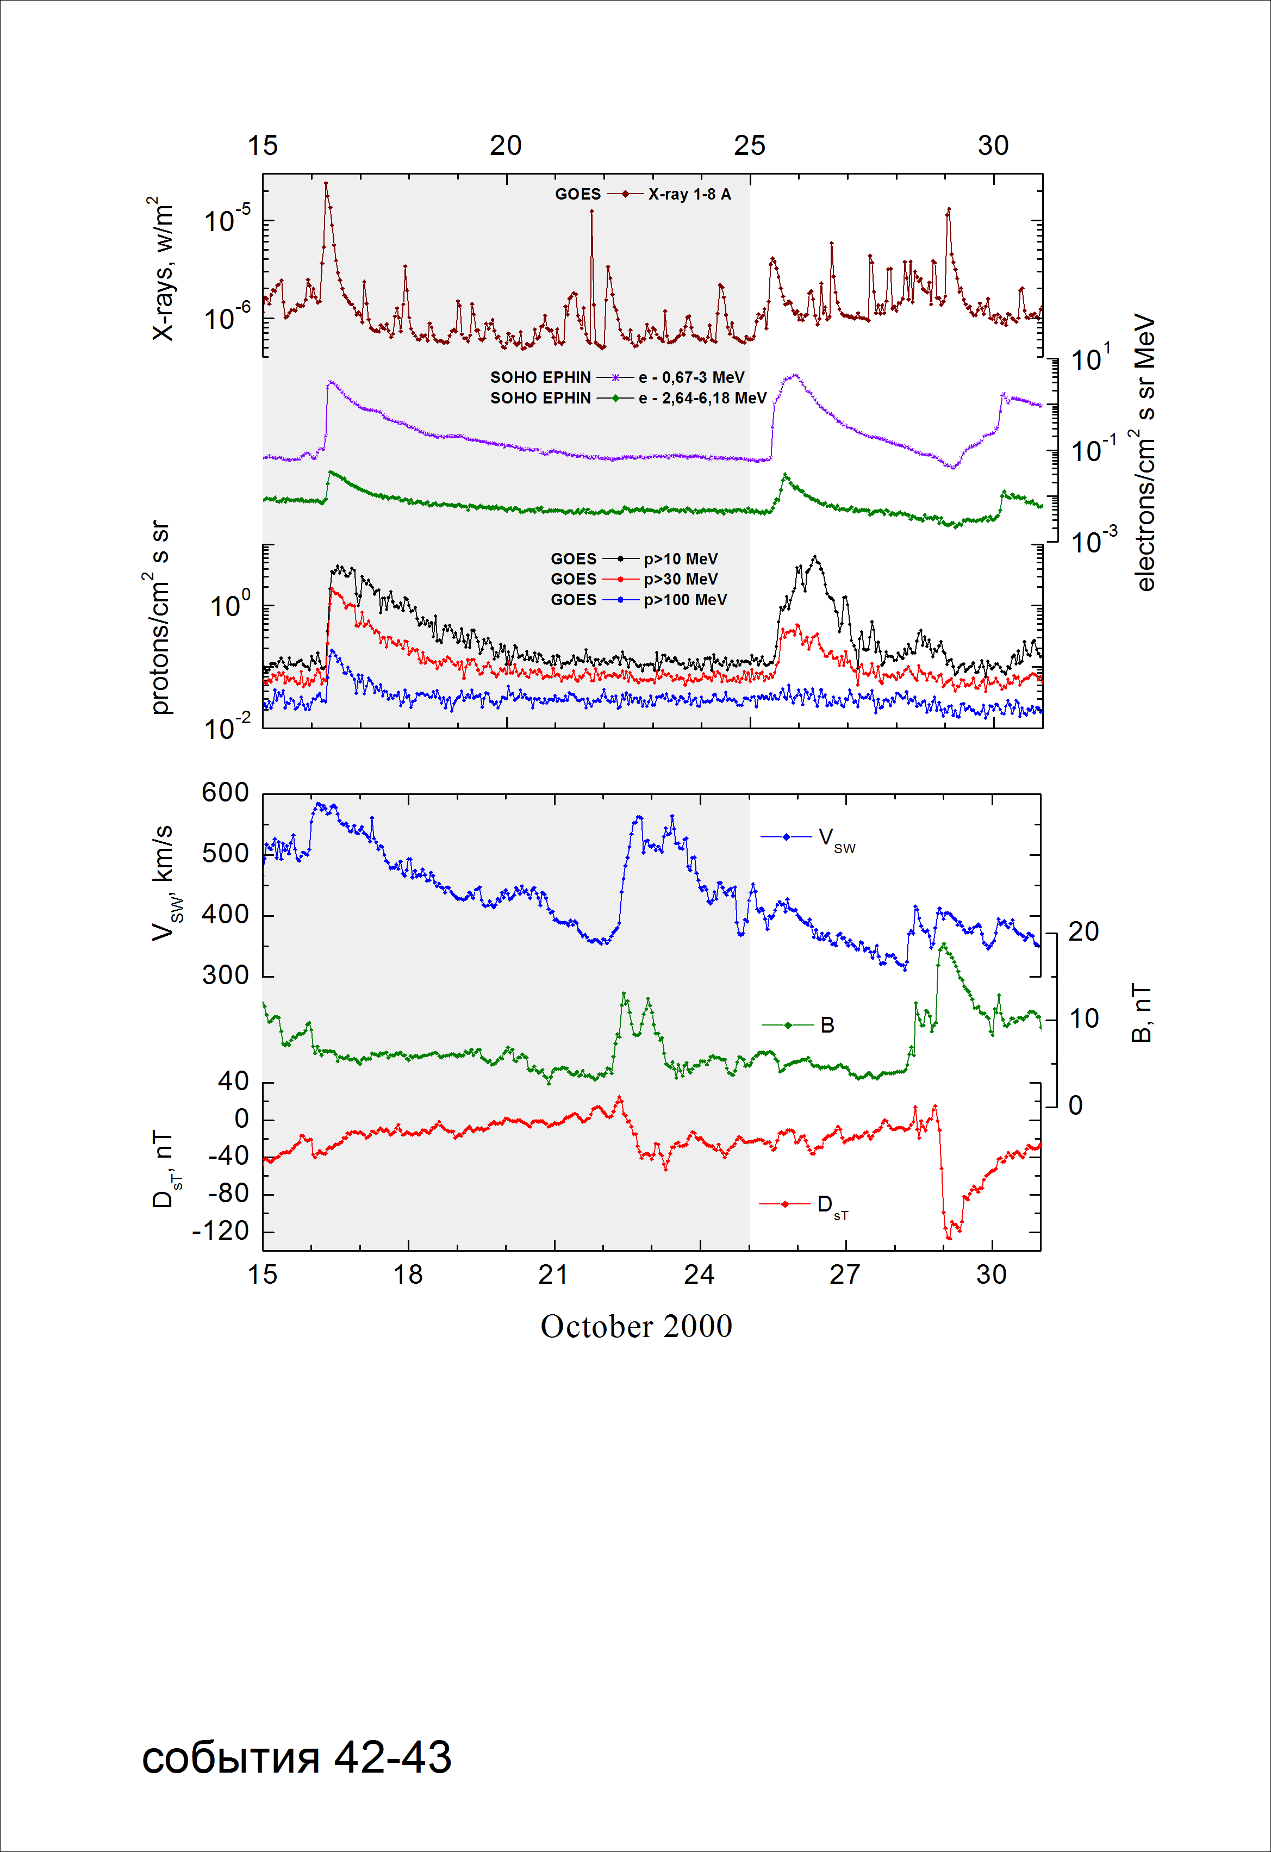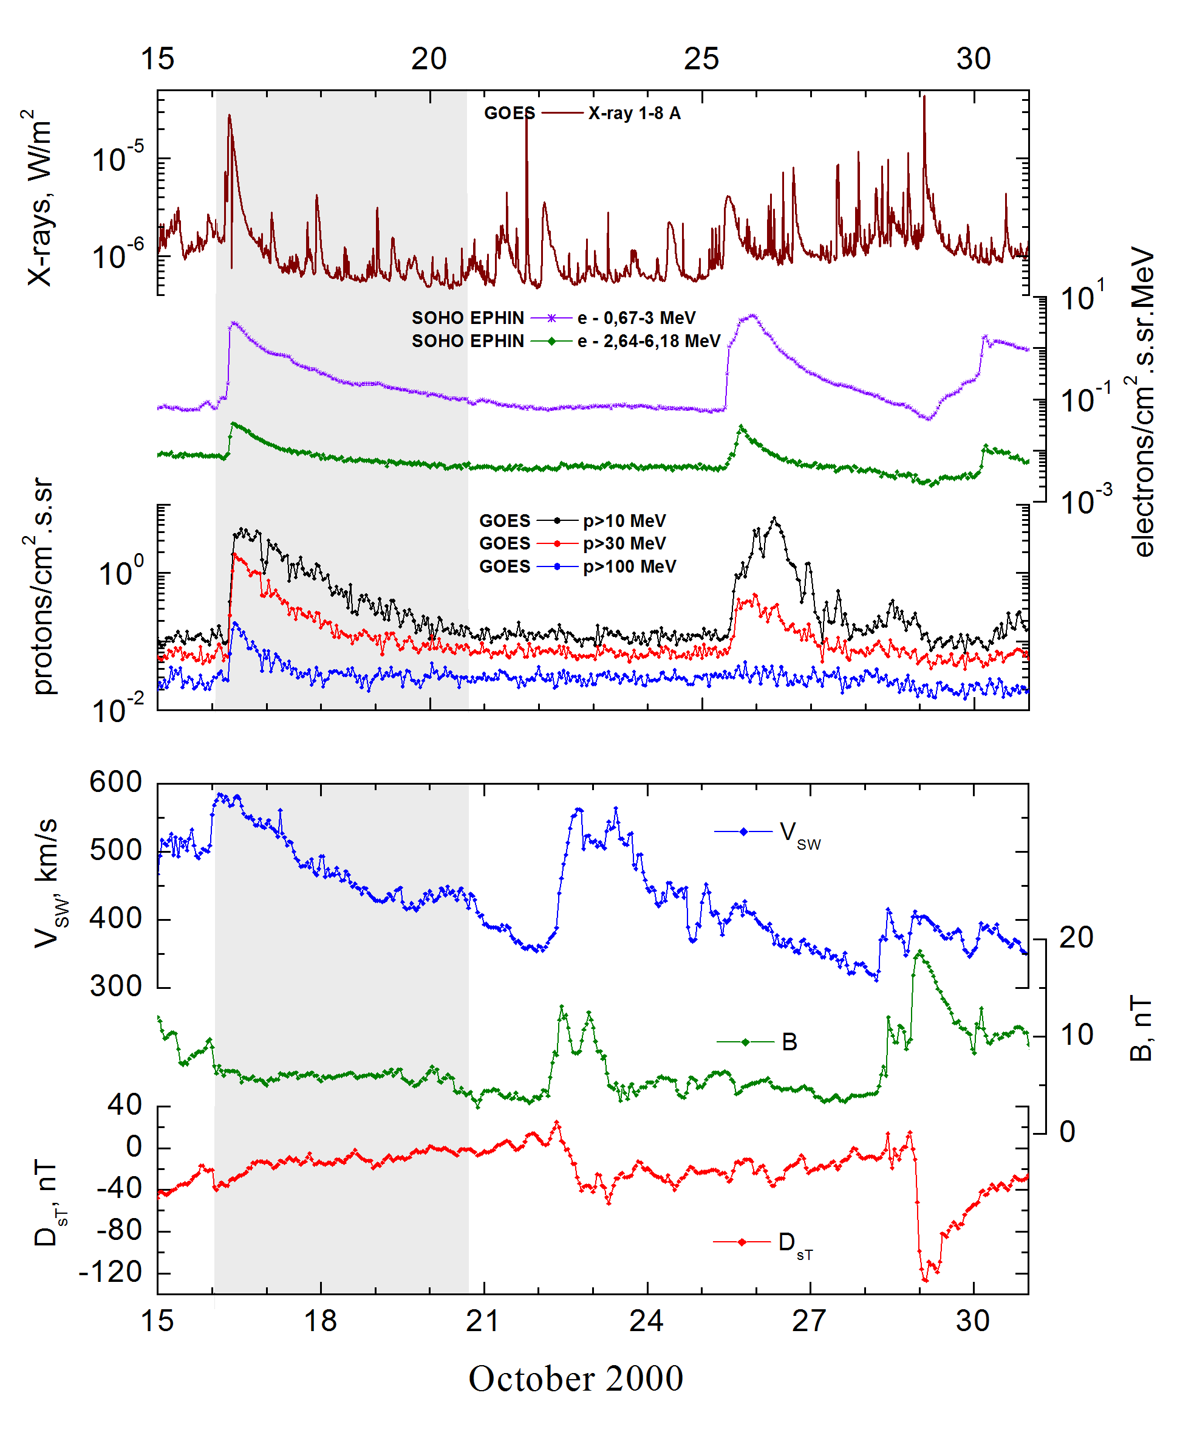
Integral time-of-maximum proton spectrum 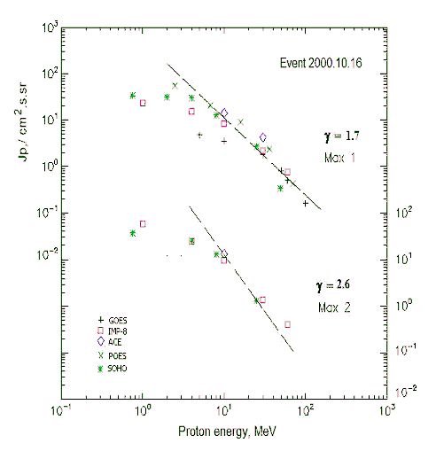

Integral fluxes of protons for the event of 2000 October 16

S/c, instruments | Eр, MeV | To | Tmax | Jmax,  /cm².s.sr | Dura-tion | Comments
GOES-10
EPS | >5 | 08^{h} | 11^{h}/ - | 4.8/ - | 4d
EPS | >10 | 08^{h} | 11^{h}/ - | 3.5/ - | 4d
EPS | >30 | 08^{h} | 11^{h}/ - | 1.8/ - | 3d
EPS | >50 | 08^{h} | 11^{h}/ - | 0.8/ - | 3d
EPS | >60 | 08^{h} | 11^{h}/ - | 0.5/ - | 2d
EPS | >100 | 08^{h} | 11^{h}/ - | 0.16/ - | 1.5d
POES-16
MEPED | >0.24 | - | - | - | -
MEPED | >0.8 | - | - | - | -
MEPED | >2.5 | - | 12^{h}/ - | 56/ - | 4d
MEPED | >6.9 | - | 12^{h}/ - | 25/ - | 4d
MEPED | >16 | - | 12^{h}/ - | 9.1/ - | 3d
MEPED | >36 | - | 12^{h}/ - | 2.5/ - | 3d
MEPED | >70 | - | 12^{h}/ - | 0.42/ - | 2d
MEPED | >140 | - | - | - | -
IMP-8
CPME | >1 | 08^{h} | 11^{h}/17^{h} | 23.2/61 | 6 d
CPME | >4 | 08^{h} | 11^{h}/18^{h} | 15.2/25 | 5 d
CPME | >10 | 08^{h} | 11^{h}/17^{h} | 8.5/9.8 | 4 d
CPME | >30 | 08^{h} | 12 ^{h}/17^{h} | 2.2/1.4 | 2 d
CPME | >60 | 08^{h} | 12^{h}/17^{h} | 0.75/0.4 | 1 d
ACE
SIS | >10 | 08^{h} | 10^{h}/16^{h} | 13.7/14.1 | 3 d
SIS | >30 | 08^{h} | 10^{h}/ - | 4.9/ - | 2 d
SOHO
EPHIN (INT) | >50 | 08^{h} | 10^{h}/ - | 0.34/ - | 1d

Differential fluxes of protons for the event of 2000 October 16

S/c, instruments | ∆Е, MeV | To | Tmax | Jmax  /cm².s.sr.MeV | Dura-tion | Comments
IMP-8
CPME | 1-2 | 08^{h} | 13^{h}/16^{h} | 3.3/16.2 | 6d
CPME | 2-4.6 | 08^{h} | 11^{h}/16^{h} | 2.6/9.4 | 6d
CPME | 4.6-15 | 08^{h} | 11^{h}/16^{h} | 0.66/1.6 | 6d
CPME | 15-25 | 08^{h} | 11^{h}/16^{h} | 0.4/0.43 | 4d
CPME | 25-48 | 08^{h} | 11^{h}/16^{h} | 0.08/0.06 | 3d
CPME | 48-96 | 08^{h} | 11^{h}/16^{h} | 0.014/0.01 | 2d
CPME | 96-145 | 08^{h} | - | - | -
CPME | 145-440 | 08^{h} | - | - | -
SOHO
LION | 0,75-2 | 08^{h} | 11^{h}/16^{h} | 1.3/4.8 | 7d
LION | 2-6 | 08^{h} | 11^{h}/16^{h} | 0.3/1.1 | 7d
EPHIN | 4-8 | 08^{h} | 11^{h}/16^{h} | 0.78/3.2 | 7d
EPHIN | 8-25 | 08^{h} | 11^{h}/16^{h} | 0.22/0.7 | 6d
EPHIN | 25-41 | 08^{h} | 11^{h}/16^{h} | 0.053/0.06 | 6d
EPHIN | 41-53 | - “ - | - “ - | - “ - | - “ -

References:
No information on publications, excepting for:
http://www.swpc.noaa.gov/ftpdir/indices/SPE.txt

Замечания:

Сократить затемнение картинки до 21 октября

