Event 2000.10.31 – (2000-305)

Particle event: To(Ep>10 MeV) – 31d07^{h}
Tmax(Ep>10 MeV) – 01d03^{h}, Jmax (Ep>10 MeV) – 2.1/cm².s.sr
Duration of the event – 3 days
Energy of the SCR and 0.1 GCR fluxes balance – Eb = 70 MeV

Sources: o solar flare 31d02^{h}51^{m}, C6.0/1N, S20E08, АR9209
Main X-ray burst 1-8 Ǻ: onset – 31d02^{h}51^{m}, max – 31d03^{h}00^{m}, Ф = 0.0036 J/m²
CME: 31d03^{h}50^{m}, V = 0074 km/s, Δφ = 189º, dA = 113º
▲SC 31d17^{h}14^{m}

Particle fluxes and associated phenomena
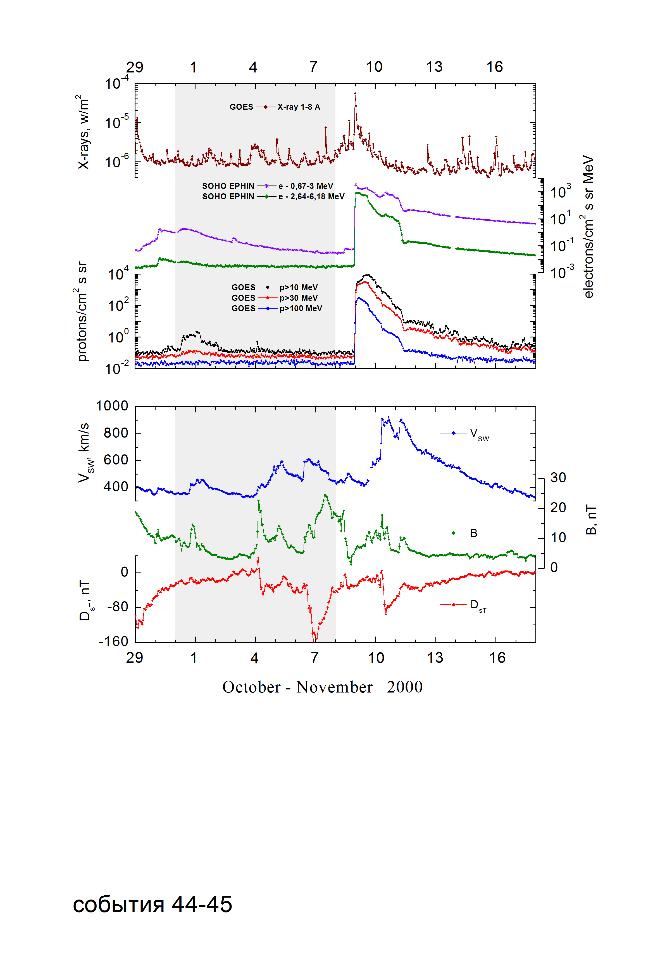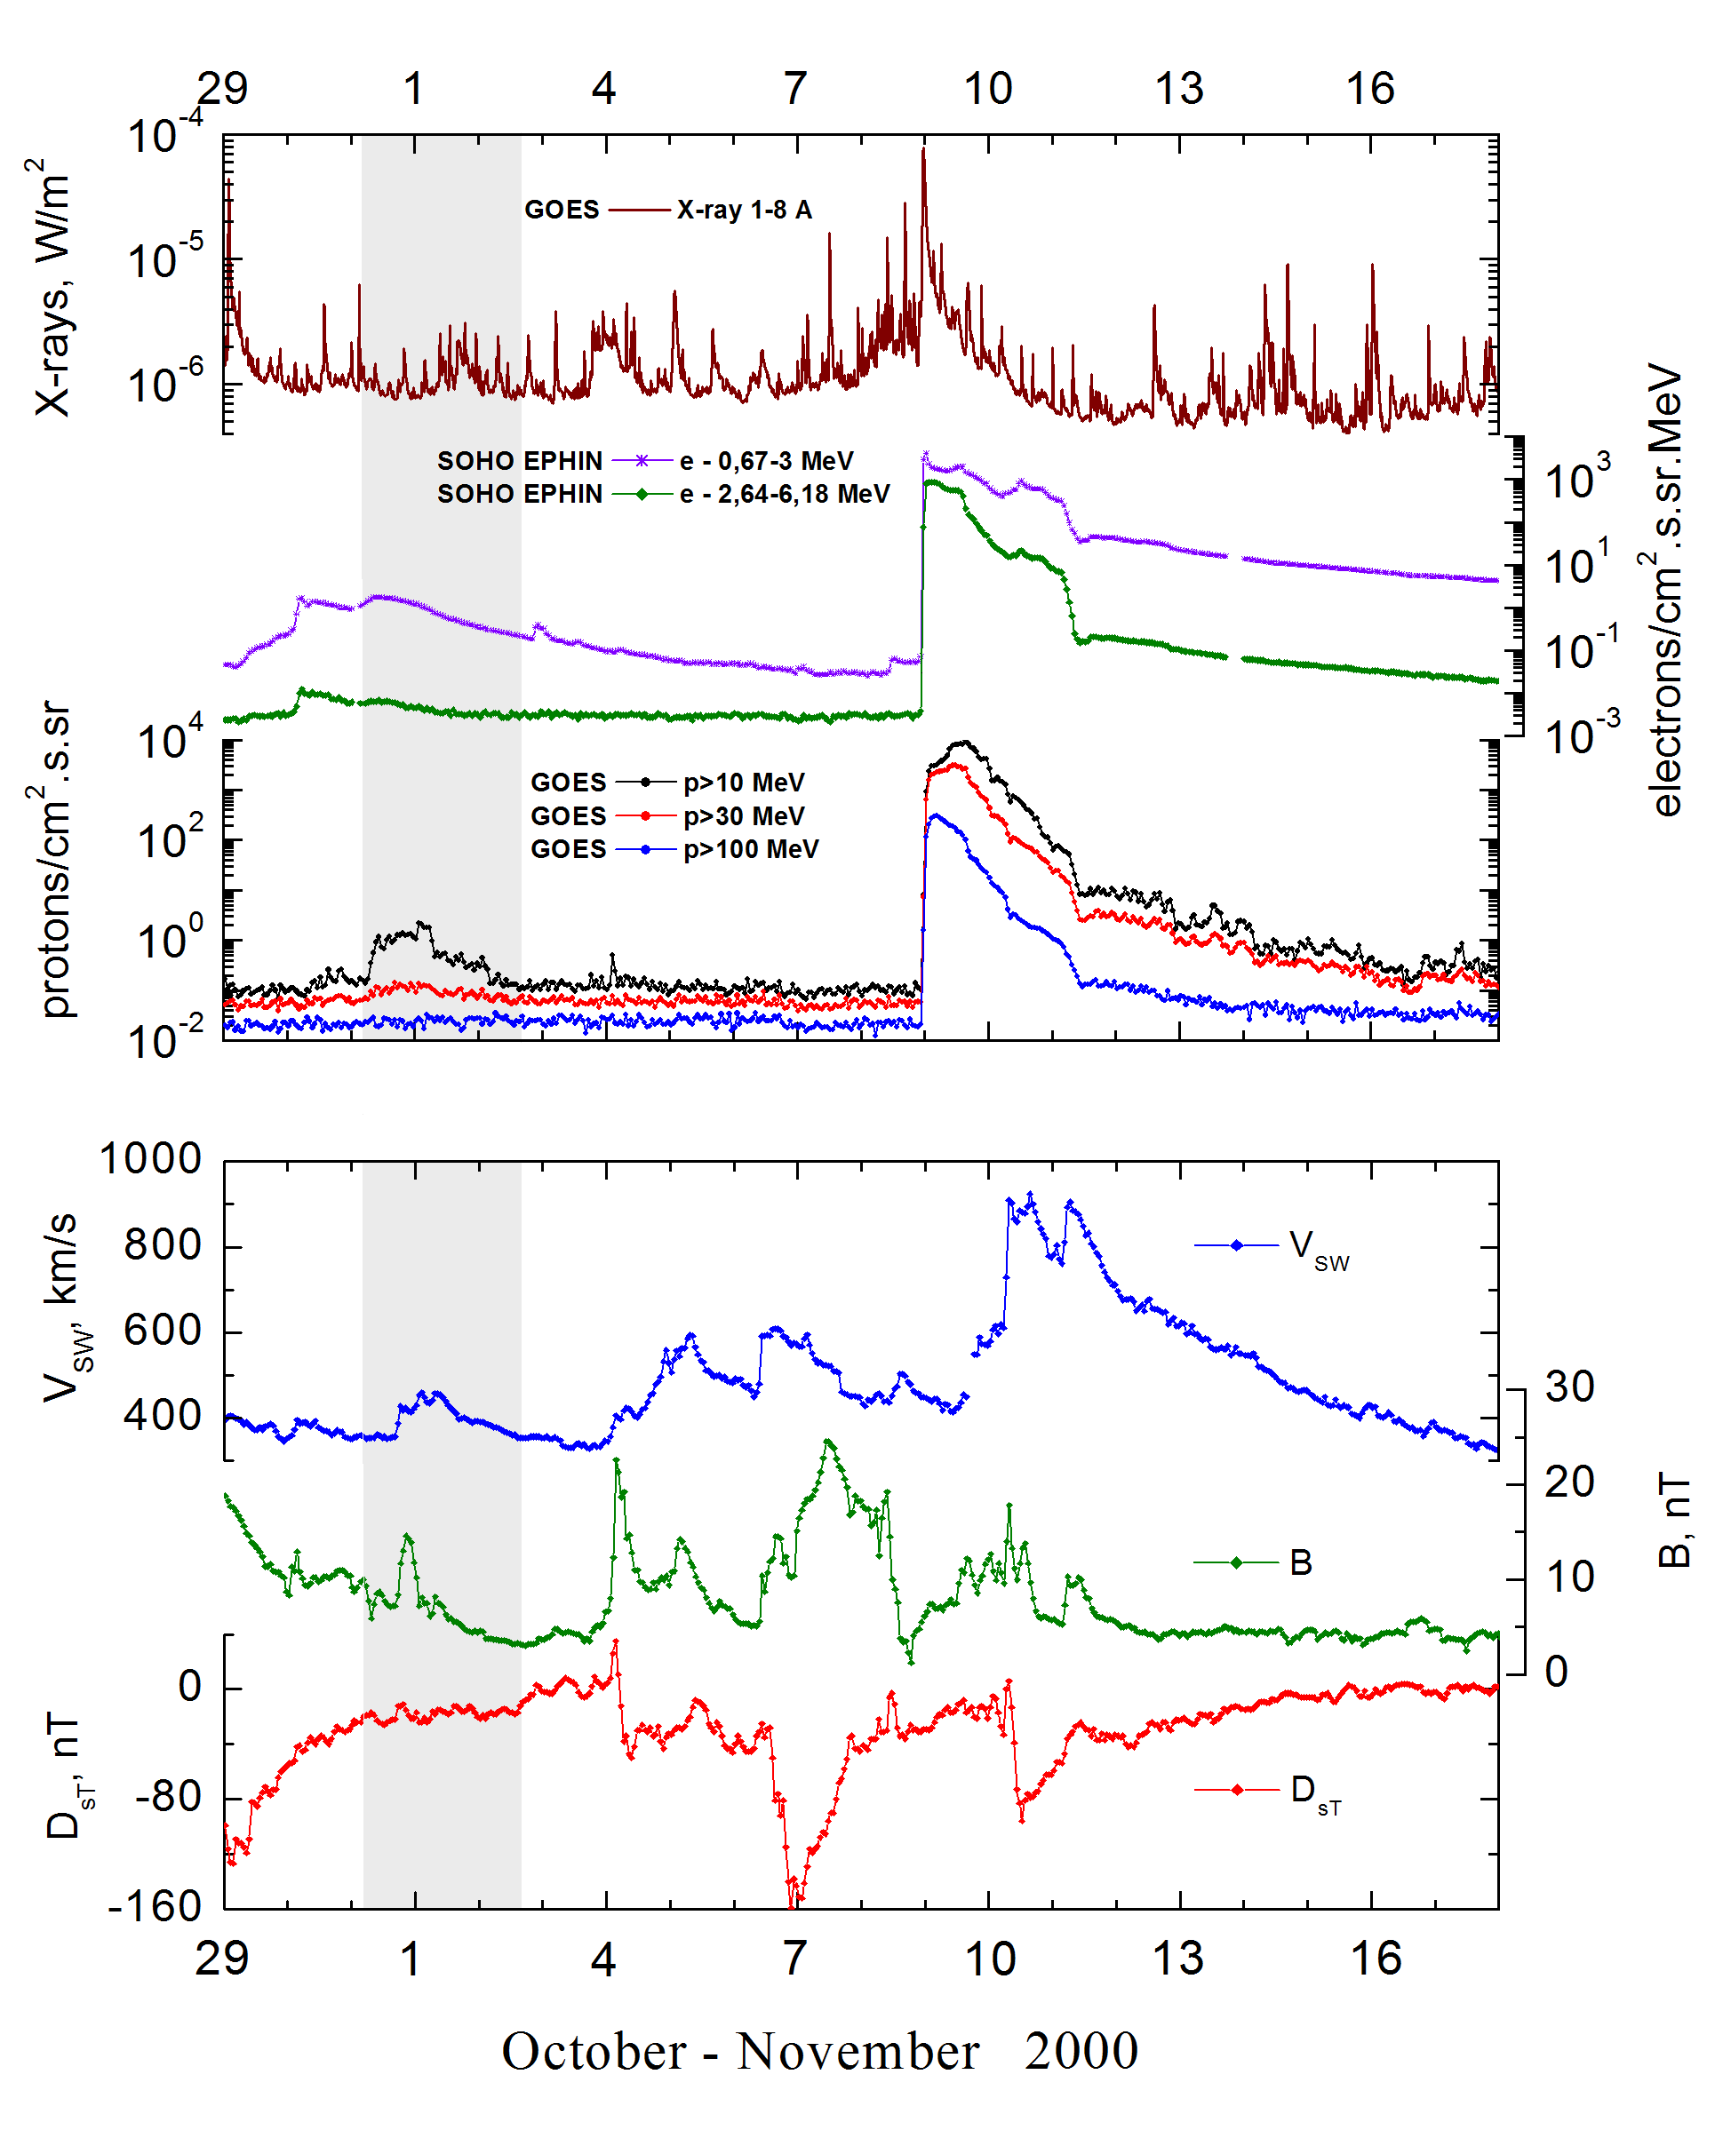

Integral time-of-maximum proton spectrum
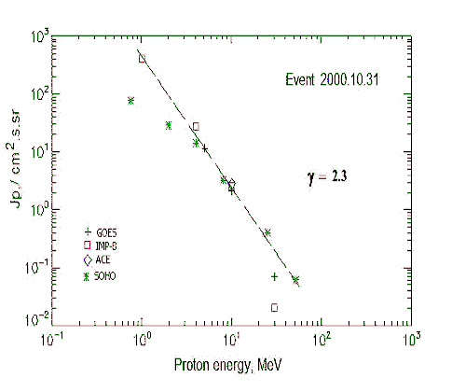

Integral fluxes of protons for the event of 2000 October 31

S/c, instruments | Eр, MeV | To | Tmax | Jmax,  /cm².s.sr | Dura-tion | Comments
GOES 10
EPS | >5 | 07^{h} | 01d03^{h} | 11.5 | 3d
EPS | >10 | 07^{h} | 01d03^{h} | 2.1 | 3d
EPS | >30 | 07^{h} | 01d01^{h} | 0.07 | 2d
EPS | >50 | - | - | - | -
EPS | >60 | - | - | - | -
EPS | >100 | - | - | - | -
IMP-8
CPME | >1 | 03^{h} | 01d02^{h} | 420 | 3d
CPME | >4 | 03^{h} | 01d02^{h} | 28 | 3d
CPME | >10 | 03^{h} | 01d02^{h} | 2.6 | 2d
CPME | >30 | 03^{h} | 01d02^{h} | 0.02 | -
CPME | >60 | - | - | - | -
ACE
SIS | >10 | 03^{h} | 01d02^{h} | 2.8 | 2d
SIS | >30 | - | -- | - | -
SOHO
EPHIN (INT) | >50 | - | 21^{h} | 0.006 | -

Differential fluxes of protons for the event of 2000 October 31

S/c, instruments | ∆Е, MeV | To | Tmax | Jmax  /cm².s.sr.MeV | Dura-tion | Comments
IMP-8
CPME | 1-2 | 06^{h} | 01d02^{h} | 315 | 3d
CPME | 2-4.6 | 06^{h} | 01d02^{h} | 43.8 | 3d
CPME | 4.6-15 | 06^{h} | 01d02^{h} | 1.9 | 3d
CPME | 15-25 | 06^{h} | 01d02^{h} | 0.06 | 3d
CPME | 25-48 | 06^{h} | 01d02^{h} | 0.0018 | 2d
CPME | 48-96 | - | - | - | -
CPME | 96-145 | - | - | - | -
CPME | 145-440 | - | - | - | -
SOHO
LION | 0,75-2 | 05^{h} | 01d02^{h} | 28 | 3d
LION | 2-6 | 05^{h} | 01d02^{h} | 3.7 | 3d
EPHIN | 4-8 | 05^{h} | 01d02^{h} | 4.7 | 3d
EPHIN | 8-25 | 05^{h} | 01d02^{h} | 0.22 | 3d
EPHIN | 25-41 | 05^{h} | 01d02^{h} | 0.002 | 3d
EPHIN | 41-53 | - “ - | - “ - | - “ - | - “ -

References:
No information on publications, excepting for:
http://www.swpc.noaa.gov/ftpdir/indices/SPE.txt

