Event 2001.05.07 – (2001-127)

Particle event: To(Ep>10 MeV) – 07d14^{h}
Tmax₁(Ep>10 MeV) – 07d18^{h}, Jmax₁(Ep>10 MeV) – 7.7 /cm².s.sr
Tmax₂(Ep>10 MeV) – 08d12^{h}, Jmax₂(Ep>10 MeV) – 11.5 /cm².s.sr
Duration of the event – 3 days
Energy of the SCR and 0.1 GCR fluxes balance – Eb(max₁) = 80 MeV
– Eb(max₂) = 85 MeV
Sources: ⁭ activity of AR9433 5d behind West limb
§ CME: 07d12^{h}06^{m}, V=1223 km/s, Δφ =205º , dA= 267º

Particle fluxes and associated phenomena
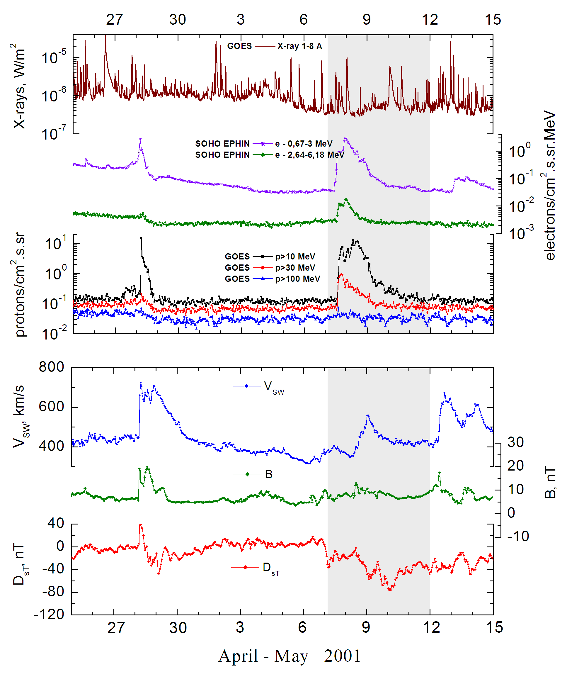

Integral time-of-maximum proton spectrum
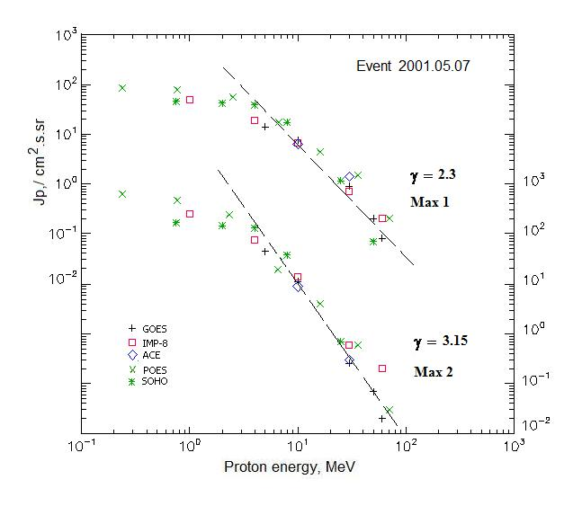

Integral fluxes of protons for the event of 2001 May 07

S/c, instruments | Eр,  MeV | To | Tmax | Jmax,  /cm².s.sr | Dura-tion | Comments
GOES-10
EPS | >5 | 14^{h} | 19^{h}/08d12^{h} | 14.2/46.6 | 3d
EPS | >10 | 14^{h} | 18^{h}/08d12^{h} | 7.7/11.5 | 3d
EPS | >30 | 14^{h} | 18^{h}/08d12^{h} | 0.9/0.26 | 2d
EPS | >50 | 14^{h} | 14^{h}/08d12^{h} | 0.2/0.07 | 1.5d
EPS | >60 | 14^{h} | 14^{h}/08d12^{h} | 0.08/ 0.02 | 1d
EPS | >100 | - | - | - | -
POES-16
MEPED | >0.24 | - | 18^{h}/08d13^{h} | 90/570 | -
MEPED | >0.8 | - | 18^{h}/08d13^{h} | 80/440 | -
MEPED | >2.5 | - | 18^{h}/08d13^{h} | 50/215 | -
MEPED | >6.9 | - | 18^{h}/08d13^{h} | 24/16 | -
MEPED | >16 | - | 18^{h}/08d13^{h} | 4.4 /4 | -
MEPED | >36 | - | 18^{h}/08d13^{h} | 1.5/0.6 | -
MEPED | >70 | - | 18^{h}/08d13^{h} | 0.2/0.03 | -
MEPED | >140 | - | - | - | -
IMP-8
CPME | >1 | 14^{h} | 19^{h}/08d12^{h} | 50.3/268 | 2.5d
CPME | >4 | 14^{h} | 19^{h}/08d11^{h} | 18.7/79 | 2.5d
CPME | >10 | 14^{h} | 18^{h}/08d09^{h} | 6.8/14 | 2d
CPME | >30 | 14^{h} | 18^{h}/08d08^{h} | 0.7/0.6 | 1d
CPME | >60 | 14^{h} | 18^{h}/08d08^{h} | 0.2/0.2 | 1d
ACE
SIS | >10 | 14^{h} | 18^{h}/08d13^{h} | 6.4/9 | 2d
SIS | >30 | 14^{h} | 18^{h}/08d13^{h} | 1.4/0.3 | 1d
SOHO
EPHIN (INT) | >50 | 14^{h} | 16^{h}/ - | 0.07/ - | 0.4d

Differential fluxes of protons for the event of 2001 May 07
S/c, instruments | ∆Е, MeV | To | Tmax | Jmax. /cm².s.sr.MeV | Dura-tion | Comments
IMP-8
CPME | 1-2 | 16^{h} | 18^{h}/08d13^{h} | 15.3/107 | 5d
CPME | 2-4.6 | 15^{h} | 18^{h}/08d13^{h} | 7.5/43.7 | 5d
CPME | 4.6-15 | 13^{h} | 18^{h}/08d09^{h} | 1.2/5.7 | 5d
CPME | 15-25 | 13^{h} | 18^{h}/08d08^{h} | 0.33/0.67 | 3d
CPME | 25-48 | 12^{h} | 17^{h}/08d08^{h} | 0.03/0.026 | 2d
CPME | 48-96 | 12^{h} | 16^{h}/16^{h} | 0.0037/0.001 | 1d
CPME | 96-145 | 13^{h} | - | - | -
CPME | 145-440 | - | - | - | -
SOHO
LION | 0.75-2 | 14^{h} | 19^{h}/08d09^{h} | 2.1/12.8 | 5d
LION | 2-6 | 14^{h} | 19^{h} /08d09^{h} | 0.87/4.4 | 5d
EPHIN | 4-8 | 14^{h} | 17^{h}/08d08^{h} | 5.34/24.1 | 5d
EPHIN | 8-25 | 14^{h} | 17^{h}/08d08^{h} | 0.96/2.24 | 5d
EPHIN | 25-41 | 14^{h} | 17^{h}/08d08^{h} | 0.5/0.024 | 5d
EPHIN | 41-53 | - “ - | - “ - | - “ - | - “ -

References:
No information on publications, excepting for:
http://www.swpc.noaa.gov/ftpdir/indices/SPE.txt

