Event 2001.09.15 – (2001-258)

Particle event: To(Ep>10 MeV) – 15d12^{h}
Tmax(Ep>10 MeV) – 15d15^{h}, Jmax(Ep>10 MeV) – 6 /cm².s.sr
Duration of the event – 2 days
Energy of the SCR and 0.1 GCR fluxes balance – Eb = 150 MeV

Sources: ● solar flare 15d11^{h}28^{m}, M1.5/1N, S21W49, АR9608
Main X-ray burst 1-8 Ǻ: onset – 15d11^{h}04^{m}, max – 15d11^{h}28^{m}, Ф = 0.037 J/m²
●CME: 15d11^{h}54^{m}, V=0478 km/s, Δφ = 130º, dA = 248˚

Particle fluxes and associated phenomena
- 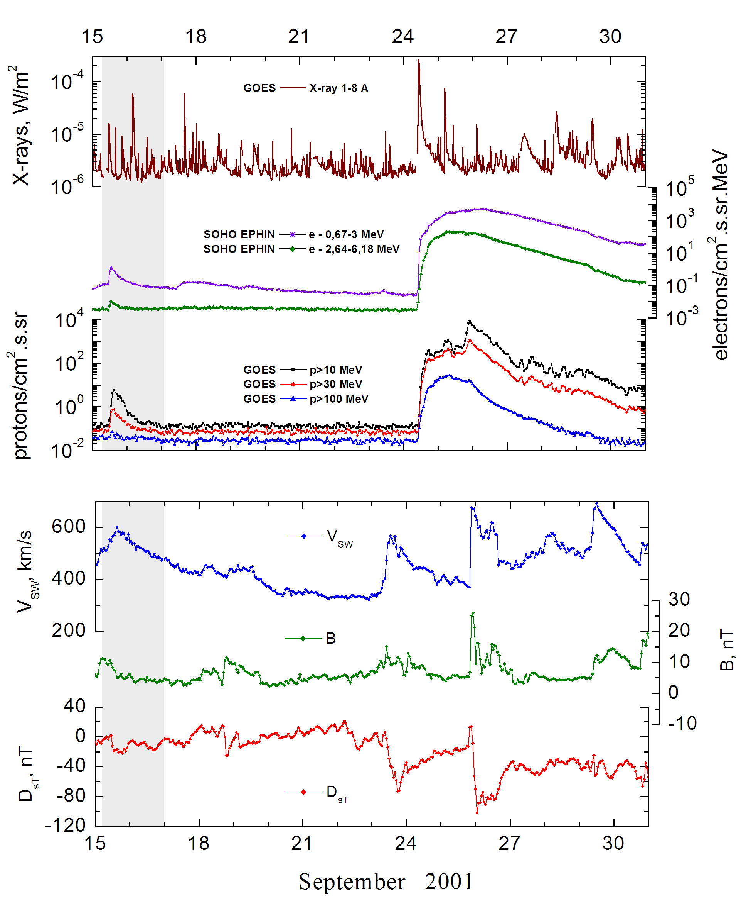

Integral time-of-maximum proton spectrum
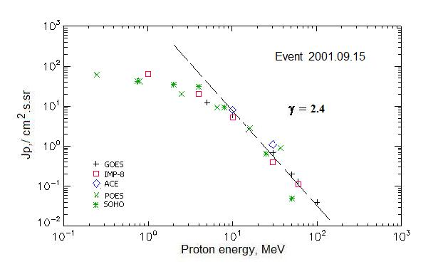

Integral fluxes of protons for the event of 2001 September 15

S/c, instruments | Eр, MeV | To | Tmax | Jmax,  /cm².s.sr | Dura-tion | Comments
GOES-10
EPS | >5 | 12^{h} | 16^{h} | 12.3 | 2d
EPS | >10 | 12^{h} | 15^{h} | 6 | 2d
EPS | >30 | 12^{h} | 15^{h} | 0.68 | 1.5d
EPS | >50 | 12^{h} | 14^{h} | 0.20 | 1.5d
EPS | >60 | 12^{h} | 14^{h} | 0.13 | 1d
EPS | >100 | 12^{h} | 14^{h} | 0.04 | 1d
POES-16
MEPED | >0.24 | 15^{h} | 15^{h} | 61 | 2d
MEPED | >0.8 | 15^{h} | 15^{h} | 41 | 2d
MEPED | >2.5 | 15^{h} | 15^{h} | 22 | 2d
MEPED | >6.9 | 15^{h} | 15^{h} | 9 | 2d
MEPED | >16 | 15^{h} | 15^{h} | 3.5 | 2d
MEPED | >36 | 15^{h} | 15^{h} | 0.9 | 2d
MEPED | >70 | 15^{h} | - | - | -
MEPED | >140 | 15^{h} | - | - | -
IMP-8
CPME | >1 | 12^{h} | 16^{h} | 65 | 2d
CPME | >4 | 12^{h} | 16^{h} | 20 | 2d
CPME | >10 | 12^{h} | 15^{h} | 5.2 | 1.5d
CPME | >30 | 12^{h} | 15^{h} | 0.4 | 0.7d
CPME | >60 | 12^{h} | 15^{h} | 0.11 | 0.5d
ACE
SIS | >10 | 12^{h} | 16^{h} | 8 | 1d
SIS | >30 | 12^{h} | 14^{h} | 1.1 | 0.7d
SOHO
EPHIN (INT) | >50 | 12^{h} | 13^{h} | 0.05 | 0.3d

Differential fluxes of protons for the event of 2001 September 15

S/c, instruments | ∆Е, MeV | To | Tmax | Jmax. /cm².s.sr.MeV | Dura-tion | Comments
IMP-8
CPME | 1-2 | 15^{h} | 18^{h} | 42 | 3d
CPME | 2-4.6 | 14^{h} | 18^{h} | 16 | 3d
CPME | 4.6-15 | 13^{h} | 18^{h} | 1.4 | 3d
CPME | 15-25 | 13^{h} | 16^{h} | 0.19 | 2d
CPME | 25-48 | 12^{h} | 15^{h} | 0.02 | 1,5d
CPME | 48-96 | 12^{h} | 15^{h} | 0.002 | 1d
CPME | 96-145 | - | - | - | -
CPME | 145-440 | - | - | - | -
SOHO
LION | 0.75-2 | 16^{h} | 18^{h} | 4.3 | 3d
LION | 2-6 | 14^{h} | 17^{h} | 1 | 3d
EPHIN | 4-8 | 13^{h} | 16^{h} | 5.3 | 3d
EPHIN | 8-25 | 13^{h} | 15^{h} | 0.51 | 3d
EPHIN | 25-41 | 12^{h} | 14^{h} | 0.03 | 2d
EPHIN | 41-53 | - “ - | - “ - | - “ - | - “ -

References:
No information on publications, excepting for:
http://www.swpc.noaa.gov/ftpdir/indices/SPE.txt

