Event 2002.03.18 – (2002-077)

Particle event: To(Ep>10 MeV) – 18d00^{h}
Tmax₁(Ep>10 MeV) – 18d15^{h}, Jmax₁(Ep>10 MeV) – 14.5 /cm².s.sr
Tmax₂(Ep>10 MeV) – 19d06^{h}, Jmax₂(Ep>10 MeV) – 20 /cm².s.sr
Duration of the event – 2days
Energy of the SCR and 0.1 GCR fluxes balance – Eb(max₁) = 155 MeV
– Eb(max₂) = 145 MeV
Sources: ๏ solar flare 17d19^{h}24^{m}, M4.0/SF, S22E16, АR9871
Ø solar flare 18d02^{h}16^{m}, M1.0/SN, S16E27, АR9871
Main X-ray burst 1-8 Ǻ: onset – 17d19^{h}24^{m}, max – 17d19^{h}31^{m}, Ф = 0.011 J/m²
CME: 17d20^{h}06^{m}, V = 823 km/s, ∆φ = 288º, dA = 276 º
▲SC 18d13^{h}23^{m};
Particle fluxes and associated phenomena
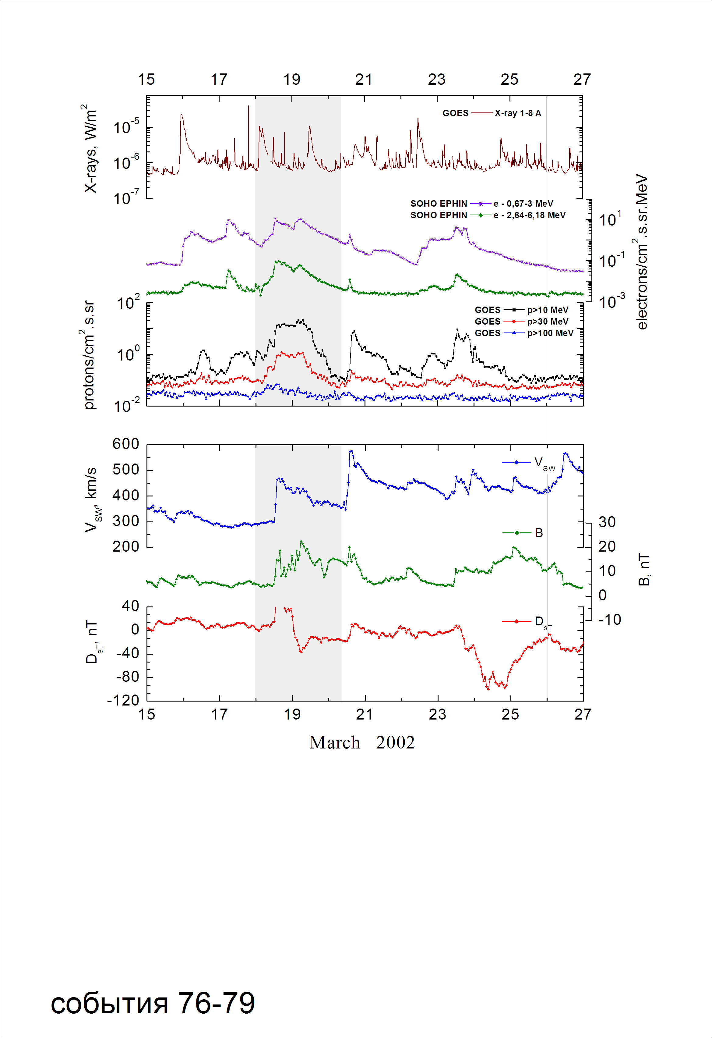

Integral time-of-maximum proton spectrum
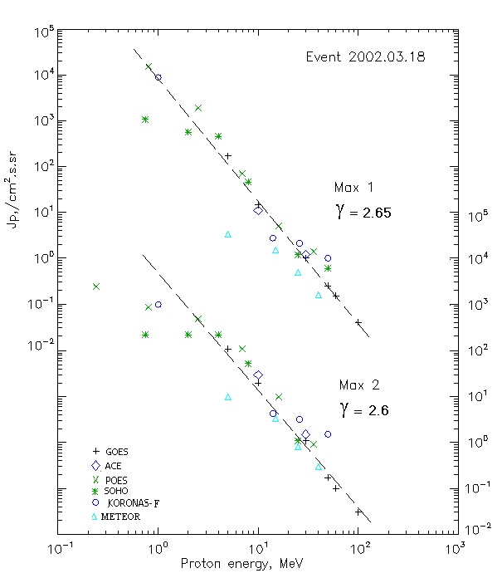

Integral fluxes of protons for the event of 2002.03.18

S/c,  instruments | Eр, MeV | To | Tmax | Jmax,  (cm².s.sr)⁻¹ | Dura-tion | Comments
GOES-10
EPS | >5 | 00^{h} | 15^{h}/19d06^{h} | 170/110 | 2d
EPS | >10 | 00^{h} | 15^{h}/19d06^{h} | 14.5/20 | 2d
EPS | >30 | 00^{h} | 17^{h}/19d07^{h} | 1/1.1 | 2d
EPS | >50 | 06^{h} | 15^{h}/19d06^{h} | 0.25/0.17 | 2d
EPS | >60 | 06^{h} | 14^{h}/19d06^{h} | 0.15/0.1 | 2d
EPS | >100 | 06^{h} | 15^{h}/19d06^{h} | 0.04/0.03 | 2d
METEOR
CBM | >5 | 08^{h} | 18^{h}/19d07^{h} | 3.4/9.8 | 3d
CBM | >15 | 07^{h} | 17^{h}/19d03^{h} | 1.5/3.3 | 2.5d
CBM | >25 | 07^{h} | 17^{h}/19d07^{h} | 0.5/0.8 | 2d
CBM | >40 | 06^{h} | 17^{h}/19d01^{h} | 0.16/0.3 | 1.5d
BP | >90 | - | - | - | -
ChD | >600 | - | - | - | -
POES-16
MEPED | >0.24 | - | - /19d07^{h} | - /2530 | 2d
MEPED | >0.8 | - | 16^{h}/19d07^{h} | 15200 /910 | 2d
MEPED | >2.5 | - | 16^{h}/19d07^{h} | 1930 /490 | 2d
MEPED | >6.9 | - | 16^{h}/19d07^{h} | 70 /110 | 2d
MEPED | >16 | - | 16^{h}/19d07^{h} | 05./10/ | 2d
MEPED | >36 | - | 16^{h}/19d06^{h} | 1.4/0.9 | 2d
MEPED | >70 | - | ⁻ | - | -
MEPED | >140 | - | ⁻ | - | -
CORONAS F
MKL | >1. | - | 15^{h}/19d09^{h} | 8850/1030 | 2d
MKL | >14 | - | 15^{h}/19d09^{h} | 2.75/4.3 | 2d
MKL | >26 | - | 15^{h}/19d09^{h} | 2.1/3.2 | 2d
MKL | >50 | - | 15^{h}/19d09^{h} | 1.0/1.5 | 2d
ACE
SIS | >10 | 07^{h} | 14^{h}/19d04^{h} | 11/30 | 1.5d
SIS | >30 | 05^{h} | 14^{h}/19d04^{h} | 1.2/1.5 | 1.5d
SOHO
EPHIN (INT) | >50 | 05^{h} | 13^{h}/ - | 0.6/ - | 1.5d

Differential fluxes of protons for the event of 2002.03.18

S/c,  instruments | ∆Е, MeV | To | Tmax | Jmax, (cm².s.sr.MeV)⁻¹ | Dura-tion | Comments
SOHO
LION | 0.75-2 | 04^{h} | 13^{h}/19d07^{h} | 290/42 | 2d
LION | 2-6 | 03^{h} | 13^{h}/19d07^{h} | 26.5/11 | 2d
EPHIN | 4-8 | 05^{h} | 13^{h}/19d06^{h} | 101/42 | 2d
EPHIN | 8-25 | 08^{h} | 13^{h}/19d06^{h} | 2.6/3.1 | 2d
EPHIN | 25-41 | 05^{h} | 13^{h}/19d05^{h} | 0.04/0.07 | 2d
EPHIN | 41-53 | - “ - | - “ - | - “ - | - “ -

References:
No information on publications, excepting for:
http://www.swpc.noaa.gov/ftpdir/indices/SPE.txt

