Event 2002.03.22 – (2002-081)

Particle event: To(Ep>10 MeV) – 22d12^{h}
Tmax₁(Ep>10 MeV) – 22d20^{h}, Jmax₁(Ep>10 MeV) – 1 /cm².s.sr
Tmax₂(Ep>10 MeV) – 23d13^{h}, Jmax₂(Ep>10 MeV) – 9 /cm².s.sr
Duration of the event – 4 days
Energy of the SCR and 0.1 GCR fluxes balance – Eb(max₁) = 40 MeV
– Eb(max₂) = 50 MeV
Sources: ■ solar flare 22d10^{h}12^{m}, M1.6/…, S10W90, АR9866
Main X-ray burst 1-8 Ǻ: onset – 22d10^{h}12^{m}, max – 22d11^{h}14^{m}, Ф = 0.049 J/m²
CME: 22d11^{h}06^{m}; V = 1750 km/s; Δφ = 360º; dA = 259º
▲SC 23d11^{h}37^{m}

Particle fluxes and associated phenomena
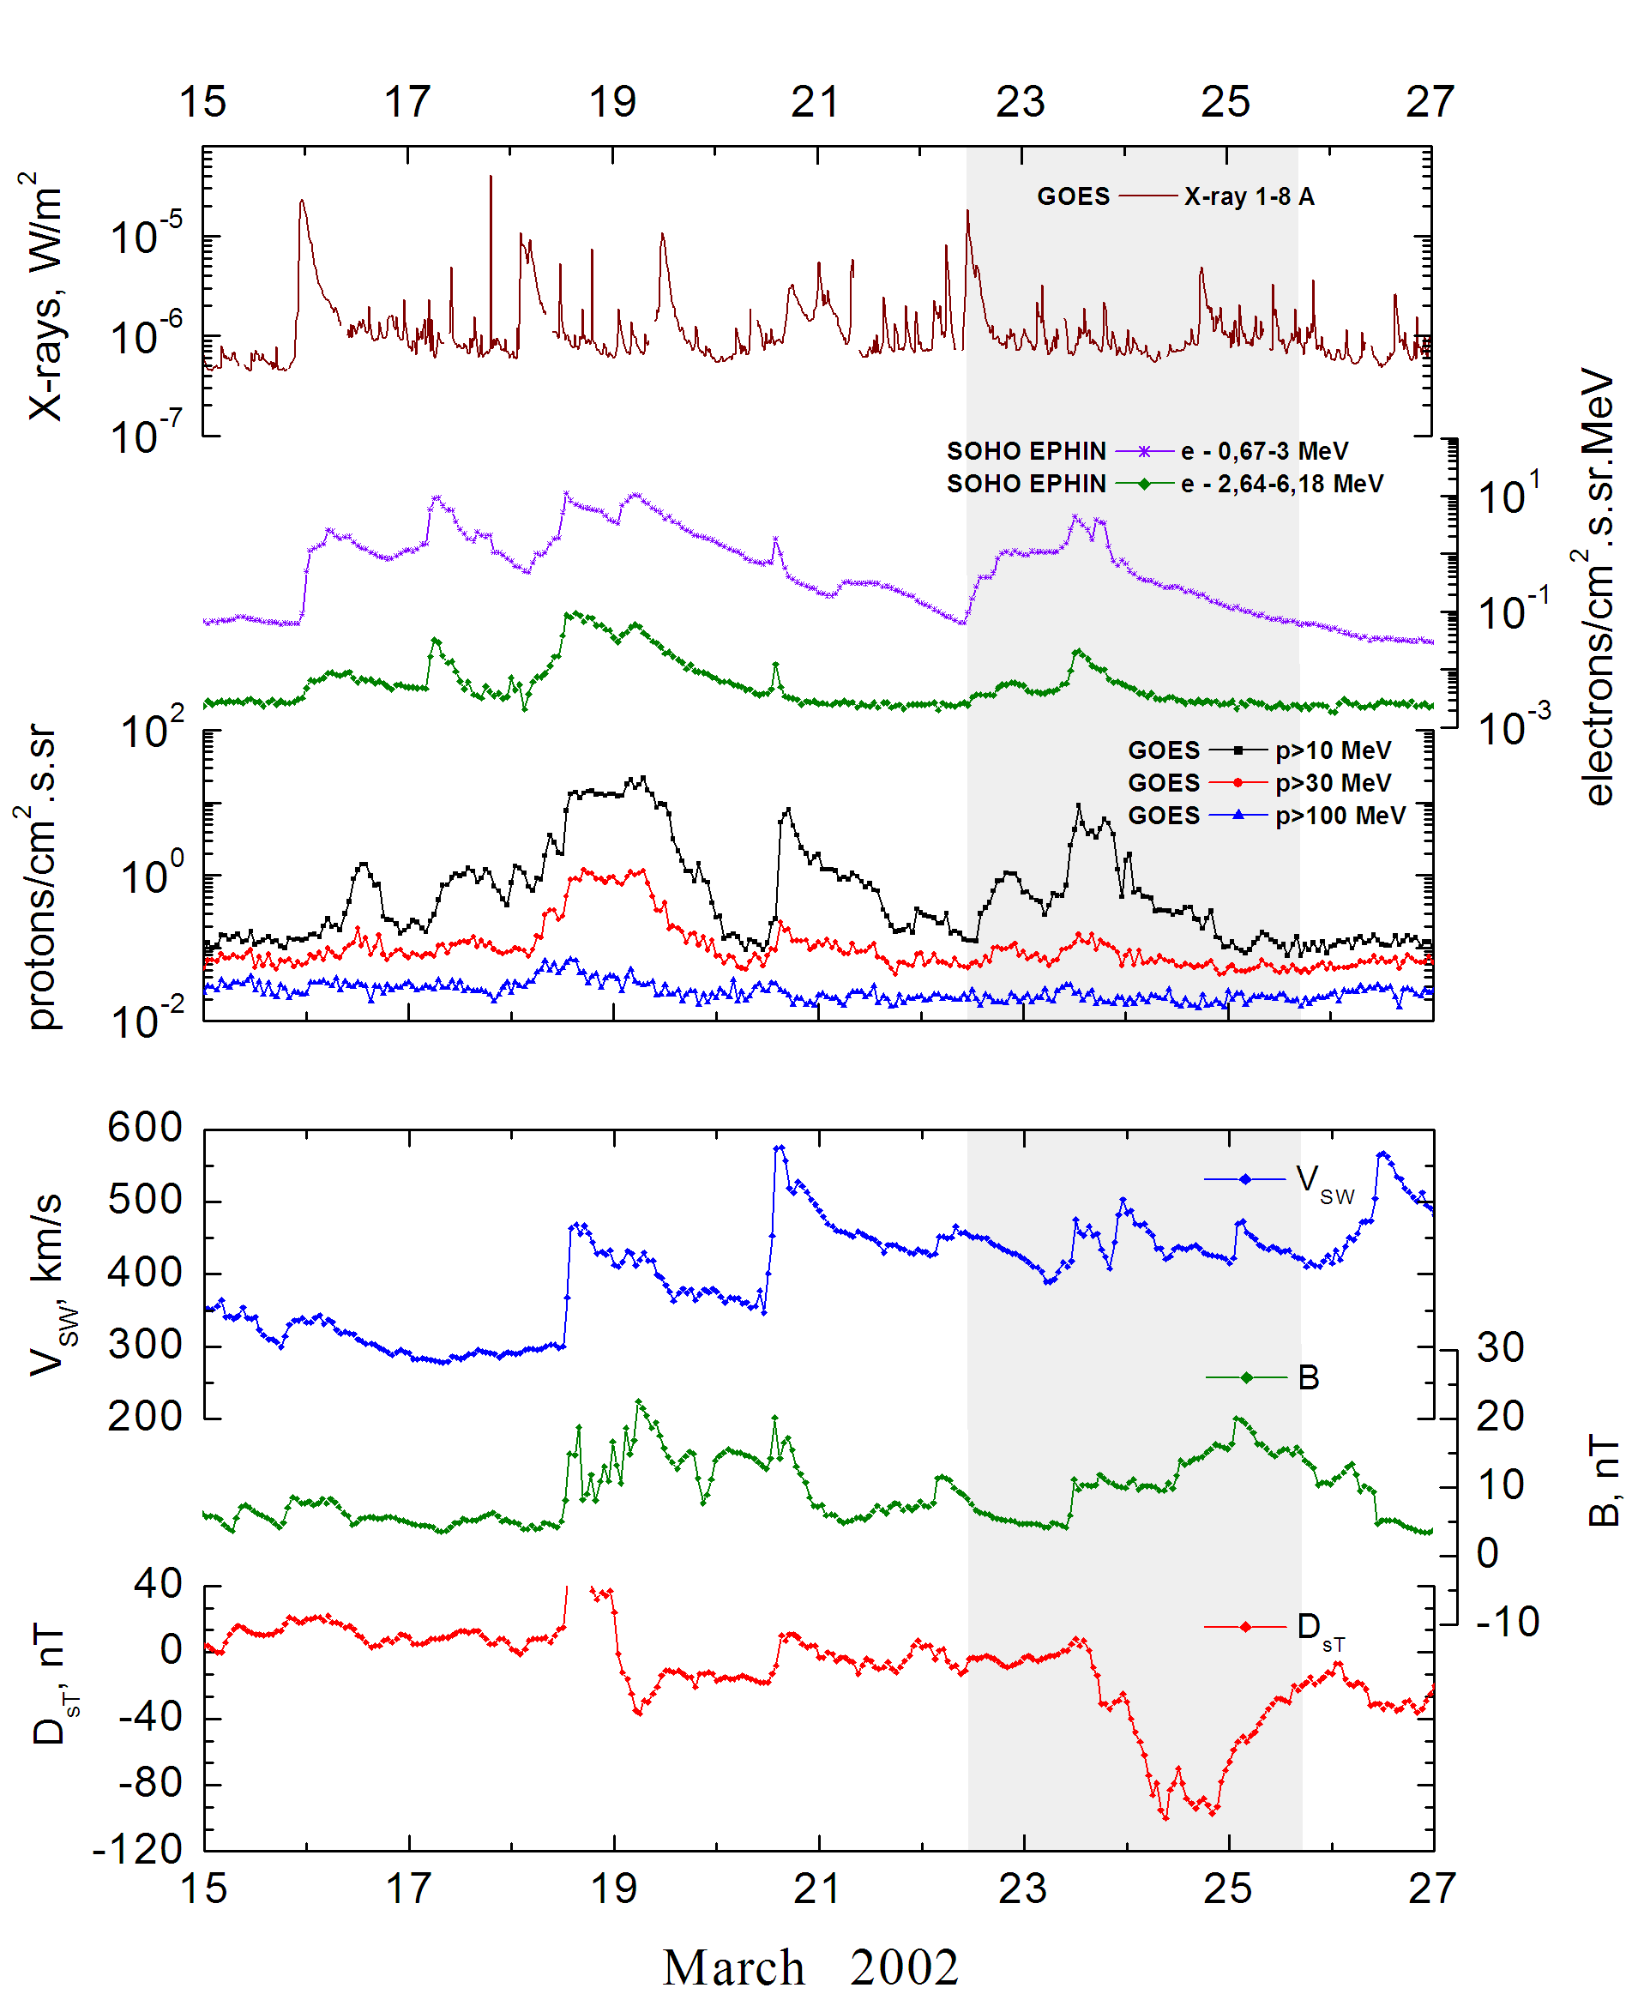
Integral time-of-maximum proton spectrum
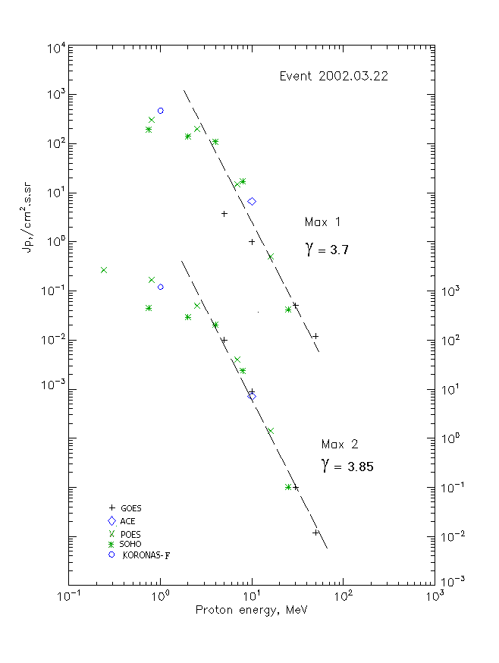

Integral fluxes of protons for the event of 2002.03.22

S/c,  instruments | Eр, MeV | To | Tmax | Jmax,  (cm².s.sr)⁻¹ | Dura-tion | Comments
GOES 10
EPS | >5 | 14^{h} | 20^{h}/23d13^{h} | 3.7/110 | 4d
EPS | >10 | 14^{h} | 20^{h}/23d13^{h} | 1/9 | 4d
EPS | >30 | - | 22^{h}/23d16^{h} | 0.05/0.1 | -
EPS | >50 | - | 22^{h}/23d16^{h} | 0.015/0.012 | -
EPS | >60 | - | - | - | -
EPS | >100 | - | - | - | -
POES 16
MEPED | >0.24 | - | 22^{h}/23d16^{h} | - /2730 | 4d
MEPED | >0.8 | - | 22^{h}/23d16^{h} | 290 /1730 | 4d
MEPED | >2.5 | - | 22^{h}/23d16^{h} | 190/510 | 4d
MEPED | >6.9 | - | 22^{h}/23d16^{h} | 15/40 | 4d
MEPED | >16 | - | 22^{h}/23d16^{h} | 0.5/1.4 | 4d
MEPED | >36 | - | - | - | -
MEPED | >70 | - | - | - | -
MEPED | >140 | - | - | - | -
CORONAS F
MKL | >1. | - | 22^{h}/23d16^{h} | 470/1230 | 4d
MKL | >14 | - | - | - | -
MKL | >26 | - | - | - | -
MKL | >50 | - | - | - | -
ACE
SIS | >10 | 13^{h} | 22^{h}/23d12^{h} | 6.7/7.2 | 2d
SIS | >30 | 10^{h} | - | - | -
SOHO
EPHIN (INT) | >50 | - | - | - | -

Differential fluxes of protons for the event of 2002.03.22

S/c,  instruments | ∆Е, MeV | To | Tmax | Jmax, (cm².s.sr.MeV)⁻¹ | Dura-tion | Comments
SOHO
LION | 0.75-2 | 15^{h} | 21^{h}/23d13^{h} | 29.5/80 | 4d
LION | 2-6 | 15^{h} | 21^{h}/23d13^{h} | 7.7/21 | 4d
EPHIN | 4-8 | 13^{h} | 20^{h}/23d12^{h} | 23/45.5 | 6d
EPHIN | 8-25 | 13^{h} | 20^{h}/23d12^{h} | 1/1.4 | 6d
EPHIN | 25-41 | 13^{h} | 19^{h}/23d13^{h} | 0.0016/0.0035 | 5d
EPHIN | 41-53 | - “ - | - “ - | - “ - | - “ -

References:
No information on publications, excepting for:
http://www.swpc.noaa.gov/ftpdir/indices/SPE.txt

