Event 2002.05.22 – (2002-142)

Particle event: To(Ep>10 MeV) – 22d07^{h}
Tmax₁(Ep>10 MeV) – 23d10^{h}, Jmax₁(Ep>10 MeV) – 260 /cm².s.sr
Tmax₂(Ep>10 MeV) – 23d16^{h}, Jmax₂(Ep>10 MeV) – 87 /cm².s.sr
Duration of the event – 2 days
Energy of the SCR and 0.1 GCR fluxes balance – Eb(max₁) = 125 MeV
– Eb(max₂) = 175 MeV

Sources: ⊙ solar flare 22d03^{h}18^{m}, C5.0/SF, S22W53, DSF;
Main X-ray burst 1-8 Ǻ: onset – 22d03^{h}18^{m}, max – 22d03^{h}54^{m}, Ф = 0.025 J/m²;
CME: 22d03^{h}50^{m}, V = 1557 km/s, ∆φ = 360º, dA = 250º;
▲SC 23d10^{h}51^{m}

Particle fluxes and associated phenomena
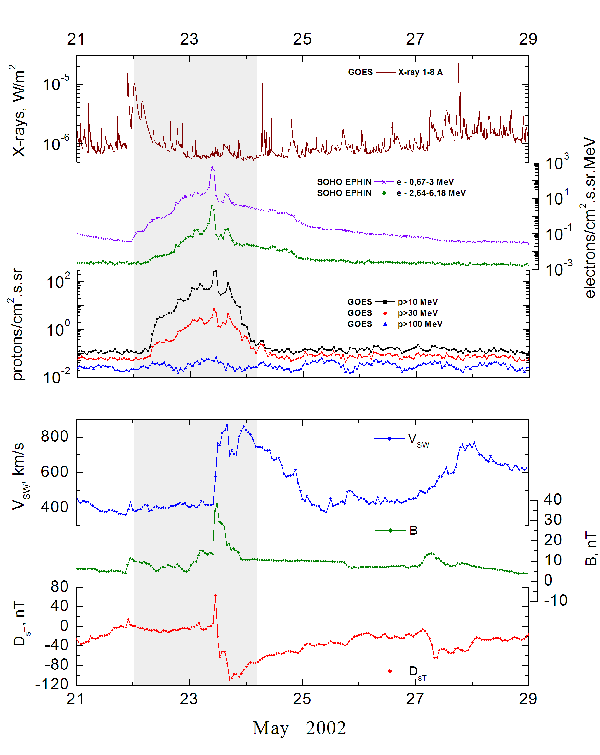
Integral time-of-maximum proton spectrum
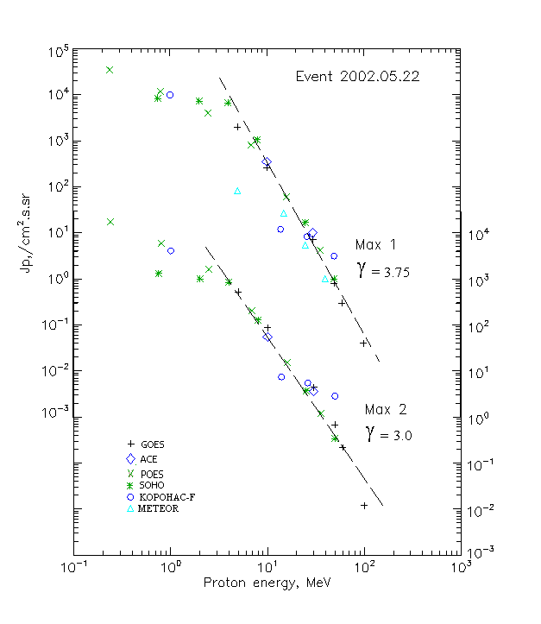

Integral fluxes of protons for the event of 2002.05.22

S/c,  instruments | Eр, MeV | To | Tmax | Jmax,  (cm².s.sr)⁻¹ | Dura-tion | Comments
GOES-10
EPS | >5 | 07^{h} | 23d11^{h}/23d16^{h} | 2120/520 | 2d
EPS | >10 | 07^{h} | 23d10^{h}/23d16^{h} | 260/87 | 2d
EPS | >30 | 07^{h} | 23d10^{h}/23d16^{h} | 7.2/4.4 | 2d
EPS | >50 | 07^{h} | 23d10^{h}/23d16^{h} | 0.8/0.67 | 2d
EPS | >60 | 07^{h} | 23d10^{h}/23d16^{h} | 0.3/0.22 | 2d
EPS | >100 | 07^{h} | 23d10^{h}/23d16^{h} | 0.04/0.012 | 2d
METEOR
CBM | >5 | 08^{h} | 23d11^{h}/ - | 83/ - | 3d
CBM | >15 | 08^{h} | 23d11^{h}/ - | 27/ - | 3d
CBM | >25 | 08^{h} | 23d11^{h}/ - | 5.3/ - | 3d
CBM | >40 | 08^{h} | 23d11^{h}/ - | 1/ - | 2d
BP | >90 | - | - | - | -
ChD | >600 | - | - | - | -
POES-16
MEPED | >0.24 | - | 23d11^{h}/23d16^{h} | 35280/ 17140 | 2d
MEPED | >0.8 | - | 23d11^{h}/23d16^{h} | 12310/ 6130 | 2d
MEPED | >2.5 | - | 23d11^{h}/23d16^{h} | 4240/1610 | 2d
MEPED | >6.9 | - | 23d11^{h}/23d16^{h} | 830/190 | 2d
MEPED | >16 | - | 23d11^{h}/23d16^{h} | 60/15 | 2d
MEPED | >36 | - | 23d11^{h}/23d16^{h} | 4.2/1.3 | 2d
MEPED | >70 | - | - | - | -
MEPED | >140 | - | - | - | -
CORONAS F
MKL | >1. | - | 23d12^{h}/23d16^{h} | 9970/4080 | 2d
MKL | >14 | - | 23d12^{h}/23d16^{h} | 12/7.4 | 2d
MKL | >26 | - | 23d12^{h}/23d16^{h} | 8.2/5.5 | 2d
MKL | >50 | - | 23d12^{h}/23d16^{h} | 3.14/2.85 | 2d
ACE
SIS | >10 | 06^{h} | 23d10^{h}/23d15^{h} | 320/55 | 3d
SIS | >30 | 07^{h} | 23d09^{h}/23d15^{h} | 9.7/3.6 | 3d
SOHO
EPHIN (INT) | >50 | 07^{h} | 23d09^{h}/23d15^{h} | 1/0.34 | 1d

Differential fluxes of protons for the event of 2002.05.22

S/c.  instruments | ∆Е. MeV | To | Tmax | Jmax. (cm².s.sr.MeV)⁻¹ | Dura-tion | Comments
SOHO
LION | 0.75-2 | 07^{h} | 23d10^{h}/23d16^{h} | 730/270 | 3d
LION | 2-6 | 05^{h} | 23d10^{h}/23d16^{h} | 224/47 | 3d
EPHIN | 4-8 | 03^{h} | 23d10^{h}/23d16^{h} | 1390/179 | 3d
EPHIN | 8-25 | 02^{h} | 23d09^{h}/23d15^{h} | 61/7.3 | 3d
EPHIN | 25-41 | 02^{h} | 23d09^{h}/23d16^{h} | 0.56/0.12 | 3d
EPHIN | 41-53 | - “ - | - “ - | - “ - | - “ -

References:
Kuwabara T., Bieber J.W., Clem J., et.al., 2006.

