Event 2002.08.18 – (2002-230)

Particle event: To(Ep>10 MeV) – 18d22^{h}
Tmax₁(Ep>10 MeV) – 19d03^{h}, Jmax₁(Ep>10 MeV) – 2.3 /cm².s.sr
Tmax₂(Ep>10 MeV) – 19d12^{h}, Jmax₂(Ep>10 MeV) – 1.8 /cm².s.sr
Duration of the event – 2 days
Energy of the SCR and 0.1 GCR fluxes balance – Eb(max₁) = 75 MeV
– Eb(max₂) = 70 MeV
Sources: ● solar flare 18d21^{h}11^{m}, 1N/M2.2, S10W20, АR10069
Main X-ray burst 1–8 Ǻ: onset – 18d21^{h}12^{m}, max – 18d21^{h}25^{m}, Ф = 0.22 J/m²
CME: 18d21^{h}54^{m}, V = 0682 km/s, ∆φ = 140º, dA = 202º.

Particle fluxes and associated phenomena
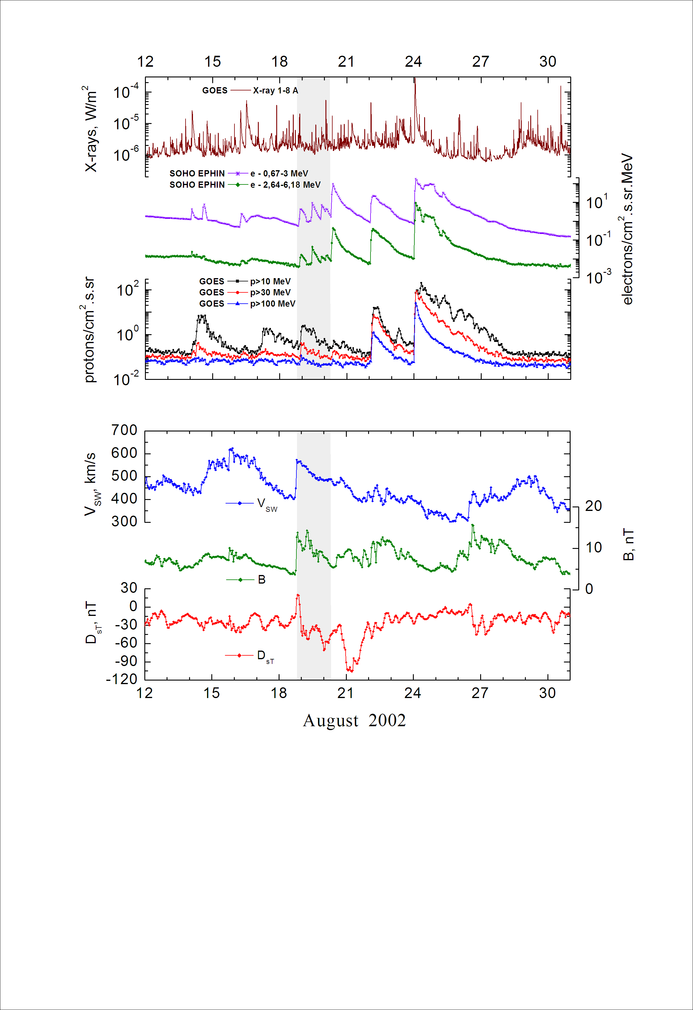
Integral time-of-maximum proton spectrum
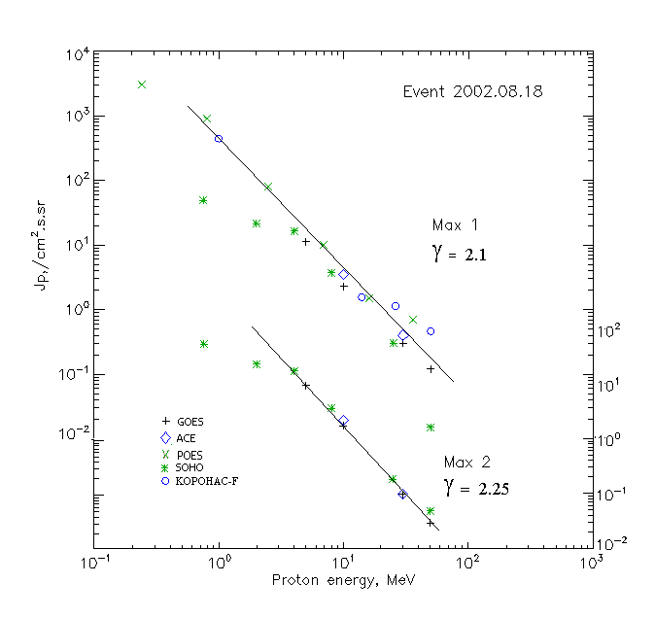

Integral fluxes of protons for the event of 2002.08.18

S/c,  instruments | Eр, MeV | To | Tmax | Jmax,  (cm2.s.sr)-1 | Dura-tion | Comments
GOES 10
EPS | >5 | 22^{h} | 19d03^{h}/19d11^{h} | 11.3/9.8 | 2d
EPS | >10 | 22^{h} | 19d03^{h}/19d12^{h} | 2.3/1.8 | 2d
EPS | >30 | 22^{h} | 19d02^{h}/19d12^{h} | 0.3/0.1 | 1.5d
EPS | >50 | 22^{h} | 19d02^{h}/19d12^{h} | 0.12/0.03 | 1.5d
EPS | >60 | - | - | - | -
EPS | >100 | - | - | - | -
POES 16
MEPED | >0.24 | - | 19d07^{h}/ - | 3120/ - | 2d
MEPED | >0.8 | - | 19d07^{h}/ - | 910/ - | 2d
MEPED | >2.5 | - | 19d05^{h}/ - | 84/ - | 2d
MEPED | >6.9 | - | 19d04^{h}/ - | 10/ - | 2d
MEPED | >16 | - | 19d02^{h}/ - | 1.5/ - | 1.5d
MEPED | >36 | - | 19d02^{h}/ - | 0.7/ - | 1.5d
MEPED | >70 | - | - | - | -
MEPED | >140 | - | - | - | -
CORONAS F
MKL | >1. | - | 19d00^{h}/ - | 445/ - | 2d
MKL | >14 | - | 19d00^{h}/ - | 1.6/ - | 1.5d
MKL | >26 | - | 19d00^{h}/ - | 1.14/ - | 1.5d
MKL | >50 | - | 19d00^{h}/ - | 0.46/ - | 1.5d
ACE
SIS | >10 | 22^{h} | 19d02^{h}/19d12^{h} | 3.5/2.25 | 2d
SIS | >30 | 22^{h} | 19d02^{h}/19d11^{h} | 0.4/0.1 | 1d
SOHO
EPHIN (INT) | >50 | 22^{h} | 19d02^{h}/19d11^{h} | 0.015/0.05 | -

Differential fluxes of protons for the event of 2002.08.18

S/c,  instruments | ∆Е, MeV | To | Tmax | Jmax, (cm².s.sr.MeV)⁻¹ | Dura-tion | Comments
SOHO
LION | 0.75-2 | 22^{h} | 19d01^{h}/19d11^{h} | 22/25.2 | 2d
LION | 2-6 | 22^{h} | 19d01^{h}/19d11^{h} | 1.6/2 | 2d
EPHIN | 4-8 | 22^{h} | 19d03^{h}/19d11^{h} | 3.2/3.6 | 2d
EPHIN | 8-25 | 22^{h} | 19d03^{h}/19d11^{h} | 0.2/0.21 | 2d
EPHIN | 25-41 | 22^{h} | 19d02^{h}/19d11^{h} | 0.01/0.005 | 2d
EPHIN | 41-53 | - “ - | - “ - | - “ - | - “ -

References:
No information on publications, excepting for:
http://www.swpc.noaa.gov/ftpdir/indices/SPE.txt

