Event 2002.09.06 – (2002-249)

Particle event: To(Ep>10 MeV) – 06d06^{h}
Tmax₁(Ep>10 MeV) – 06d14^{h}, Jmax₁(Ep>10 MeV) – 3 /cm².s.sr
Tmax₂(Ep>10 MeV) – 07d17^{h}, Jmax₂(Ep>10 MeV) – 67 /cm².s.sr
Duration of the event – 3 days
Energy of the SCR and 0.1 GCR fluxes balance – Eb(max₁) = 80 MeV
– Eb(max₂) = 175 MeV
Sources: ๏ solar flare 05d16^{h}18^{m}, C5.2/SF, N12E28, АR10102
Main X-ray burst 1-8 Ǻ: onset – 05d16^{h}18^{m}, max – 05d17^{h} 06^{m}, Ф = 0.016 J/m²
CME: 05d16^{h}54^{m}; V = 1748 km/s, ∆φ = 360º, dA = 114º
▲SC 07d16^{h}38^{m}

Particle fluxes and associated phenomena
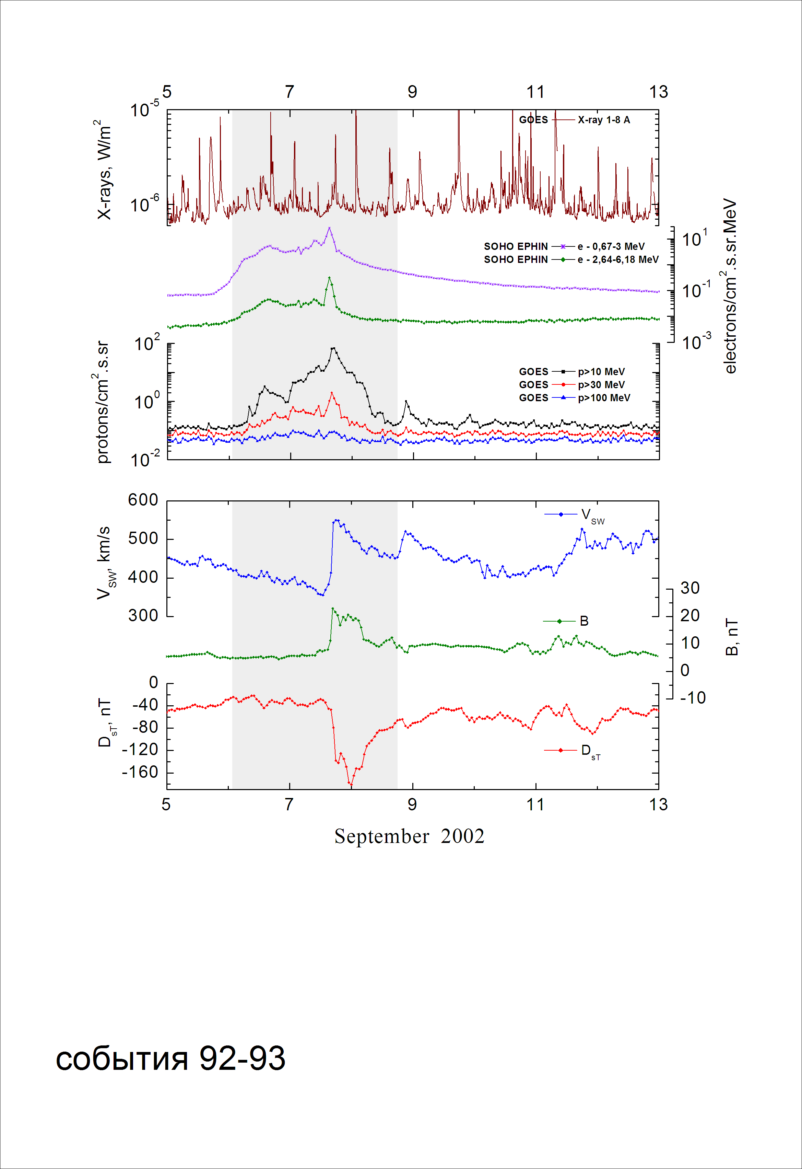
Integral time-of-maximum proton spectrum
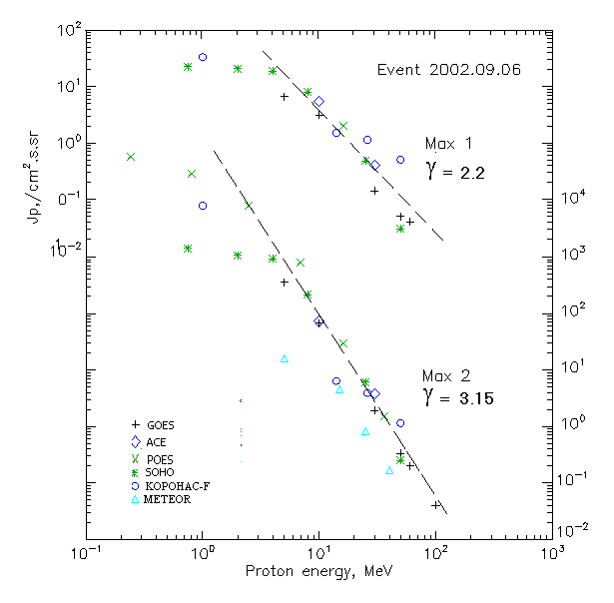

Integral fluxes of protons for the event of 2001.09.06

S/c, instruments | Eр, MeV | To | Tmax | Jmax,  (cm2.s.sr)⁻¹ | Dura-tion | Comments
GOES 10
EPS | >5 | 06^{h} | 14^{h}/07d17^{h} | 6.6/360 | 3d
EPS | >10 | 06^{h} | 14^{h}/07d17^{h} | 3/67 | 3d
EPS | >30 | 07^{h} | 13^{h}/07d16^{h} | 0.14/1.9 | 3d
EPS | >50 | 07^{h} | 13^{h}/07d16^{h} | 0.05/0.33 | 2d
EPS | >60 | 07^{h} | 13^{h}/07d16^{h} | 0.04/0.2 | 2d
EPS | >100 | 07^{h} | - /07d16^{h} | - /0.04 | 1d
METEOR
CBM | >5 | - | - /07d17^{h} | - /16 | 2d
CBM | >15 | - | - /07d17^{h} | - /4.6 | 2d
CBM | >25 | - | - /07d17^{h} | - /0.83 | 1d
CBM | >40 | - | - /07d17^{h} | - /0.17 | 1d
BP | >90 | - | - | - | -
ChD | >600 | - | - | - | -
POES 16
MEPED | >0.24 | - | 16 ^{h}/07d18^{h} | -/59300 | 3d
MEPED | >0.8 | - | 16 ^{h}/07d18^{h} | -/29600 | 3d
MEPED | >2.5 | - | 16 ^{h}/07d18^{h} | -/7870 | 3d
MEPED | >6.9 | - | 16 ^{h}/07d18^{h} | -/790 | 2d
MEPED | >16 | - | 16 ^{h}/07d18^{h} | 2/30 | 2d
MEPED | >36 | - | 16 ^{h}/07d18^{h} | -/1.5 | 1d
MEPED | >70 | - | - | - | -
MEPED | >140 | - | - | - | -
CORONAS F
MKL | >1. | - | 18 ^{h}/07d18^{h} | 33/8150 | 3d
MKL | >14 | - | 18 ^{h}/07d18^{h} | 1.5/6.4 | 2d
MKL | >26 | - | 18 ^{h}/07d18^{h} | 1.14/3.9 | 2d
MKL | >50 | - | 18 ^{h}/07d18^{h} | 0.5/1.14 | 1d
ACE
SIS | >10 | 03^{h} | 13^{h}/07d16^{h} | 5.5/72.5 | 3d
SIS | >30 | 05^{h} | 13^{h}/07d15^{h} | 0.4/3.8 | 2d
SOHO
EPHIN (INT) | >50 | - | 18^{h}/07d15^{h} | 0.03/0.25 | 0.3d

Differential fluxes of protons for the event of 2001.09.06

S/c,  instru-ments | ∆Е, MeV | To | Tmax | Jmax, (cm².s.sr.MeV)⁻¹ | Dura-tion | Comments
SOHO
LION | 0.75-2 | 05d23^{h} | 17^{h}/07d16^{h} | 1.5/285 | 4d
LION | 2-6 | 05d23^{h} | 17^{h}/07d16^{h} | 0.58/46 | 4d
EPHIN | 4-8 | 05d22^{h} | 16^{h}/07d15^{h} | 2.7/178 | 4d
EPHIN | 8-25 | 05d22^{h} | 16^{h}/07d15^{h} | 0.44/12.2 | 4d
EPHIN | 25-41 | 05d22^{h} | 15^{h}/07d15^{h} | 0.016/0.21 | 4d
EPHIN | 41-53 | - “ - | - “ - | - “ - | - “ -

References:
No information on publications, excepting for:
http://www.swpc.noaa.gov/ftpdir/indices/SPE.txt

