Event 2003.06.18 – (2003-169)

Particle event: To(Ep>10MeV) – 18d08^{h}
Tmax (Ep>10MeV) – 20d06^{h}, Jmax (Ep>10MeV) – 10.2 /cm².s.sr
Duration of the event – 2 days
Energy of the SCR and 0.1 GCR fluxes balance – Eb = 180 MeV

Sun source: ๏ solar flare 17d22^{h} 27^{m}, M6.8/..., S12E60, АR10368
Main X-ray burst 1-8 Ǻ: onset – 17d22^{h}27^{m}, max – 17d22^{h}55^{m}, Ф = 0.096 Jo.m⁻²
CME: 17d23^{h}18^{m}, V =1813 km/s, Δφ = 360º, dA = 117º
ΔSC 18d05^{h}12^{m}

Particle fluxes and associated phenomena
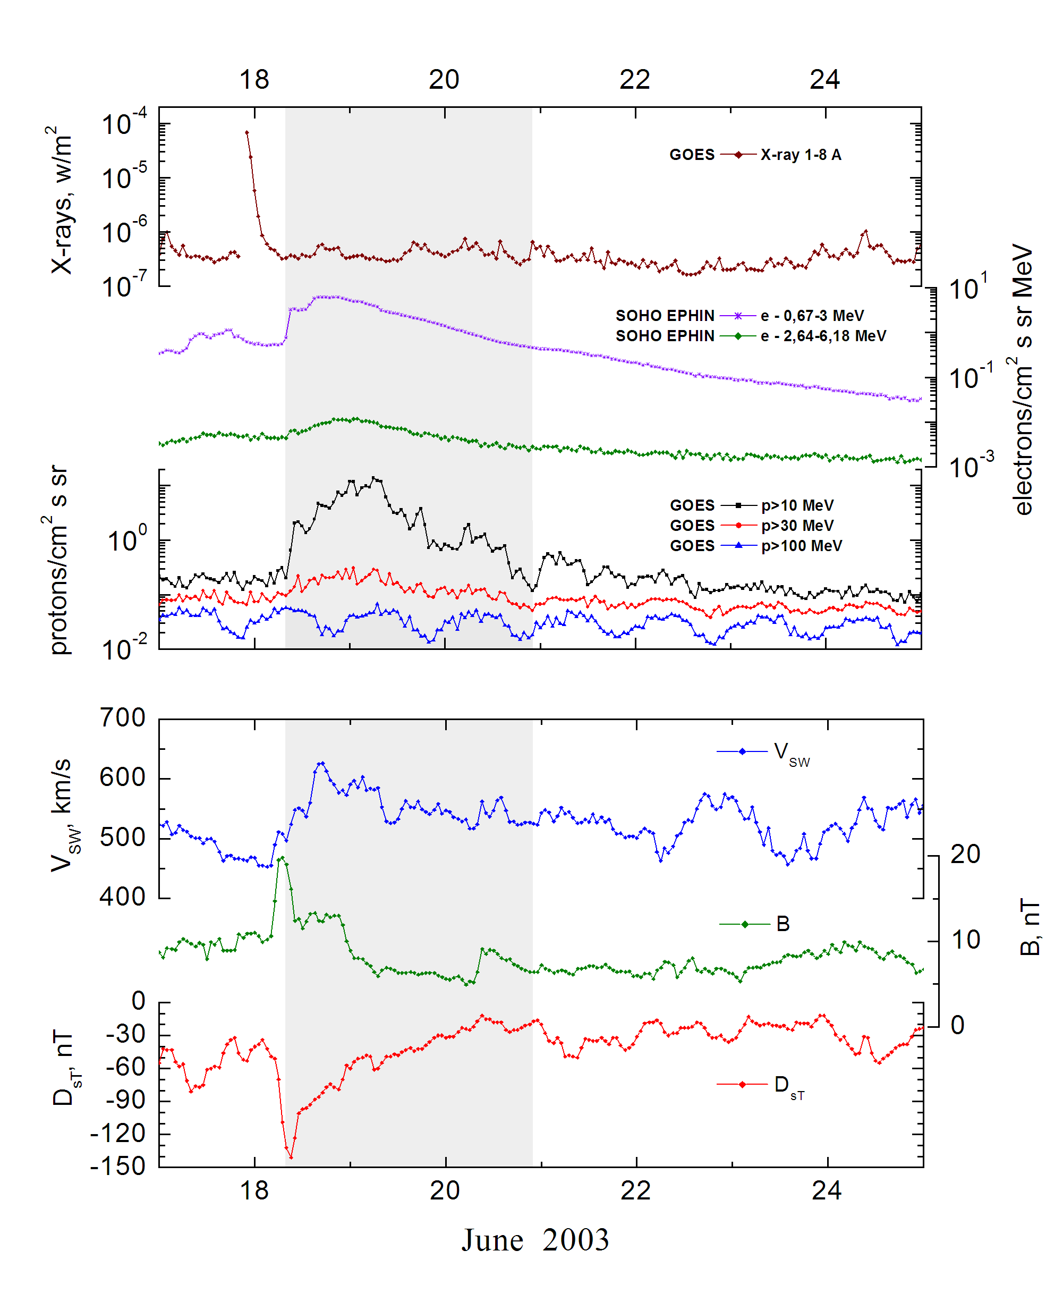

Integral time-of-maximum proton spectrum
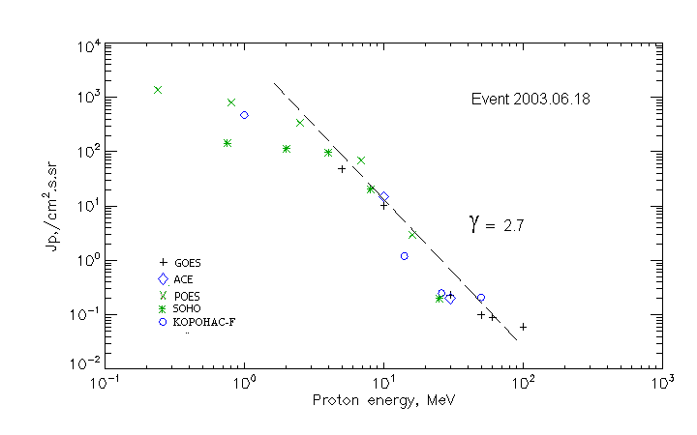

Integral fluxes of protons for the event of 2003.06.18

S/c, instruments | Eр, MeV | To | Tmax | Jmax,  (cm².s.sr)⁻¹ | Dura-tion | Comments
GOES-10
EPS | >5 | 06^{h} | 19d05^{h} | 48 | 3d
EPS | >10 | 06^{h} | 19d05^{h} | 10.2 | 3d
EPS | >30 | 06^{h} | 19d05^{h} | 0.23 | 3d
EPS | >50 | 06^{h} | 19d05^{h} | 0.1 | 3d
EPS | >60 | 06^{h} | 19d05^{h} | 0.09 | 3d
EPS | >100 | 06^{h} | 19d05^{h} | 0.06 | 3d
POES-16
MEPED | >0.24 | - | 19d05^{h} | 1400 | 2d
MEPED | >0.8 | - | 19d05^{h} | 800 | 2d
MEPED | >2.5 | - | 19d05^{h} | 340 | 2d
MEPED | >6.9 | - | 19d05^{h} | 70 | 2d
MEPED | >16 | - | 19d05^{h} | 3 | 2d
MEPED | >36 | - | - | - | 2d
MEPED | >70 | - | - | - | 1d
MEPED | >140 | - | - | - | 1d
CORONAS F
MKL | >1. | - | 19d05^{h} | 471 | 2d
MKL | >14 | - | 19d05^{h} | 1.2 | 2d
MKL | >26 | - | 19d05^{h} | 0.25 | 2d
MKL | >50 | - | 19d05^{h} | 0.21 | 1d
ACE
SIS | >10 | 07^{h} | 19d05^{h} | 15 | 3d
SIS | >30 | 07^{h} | 19d05^{h} | 0.2 | 1d
SOHO
EPHIN INT | >50 | - | - | - | -

Differential fluxes of protons for the event of 2003.06.18

S/c, instruments | ∆Е, MeV | To | Tmax | Jmax, (cm².s.sr.MeV)⁻¹ | Dura-tion | Comments
SOHO
LION | 0.75-2 | 06^{h} | 19d05^{h} | 22.4 | 8d
LION | 2-6 | 06^{h} | 19d05^{h} | 6 | 8d
EPHIN | 4-8 | 06^{h} | 19d05^{h} | 18.9 | 8d
EPHIN | 8-25 | 06^{h} | 19d05^{h} | 1.2 | 8d
EPHIN | 25-41 | 06^{h} | 19d03^{h} | 0.07 | 3d
EPHIN | 41-53 | - “ - | - “ - | - “ - | - “ -

References:
No information on publications, excepting for:
http://www.swpc.noaa.gov/ftpdir/indices/SPE.txt

