Event 2003.12.02 – (2003-336)

Particle event: To(Ep>10 MeV) – 02d12^{h}
Tmax(Ep>10 MeV) – 02d18^{h}, Jmax (Ep>10 MeV) – 21 /cm².s.sr
Duration of the event – 4.5 days
Energy of the SCR and 0.1 GCR fluxes balance – Eb = 100 MeV

Sources: ʘ solar flare 02d09^{h}40^{m}, C7.2/…, S19W90 АR10508
Main X-ray burst 1-8 Ǻ: onset – 02d09^{h}40^{m}, max – 02d09^{h}47^{m}, Ф = 0.0051 J/m²
CME: 02d10^{h}50^{m}, V = 1393 km/s, ∆φ = 150º, dA = 267º

Particle fluxes and associated phenomena
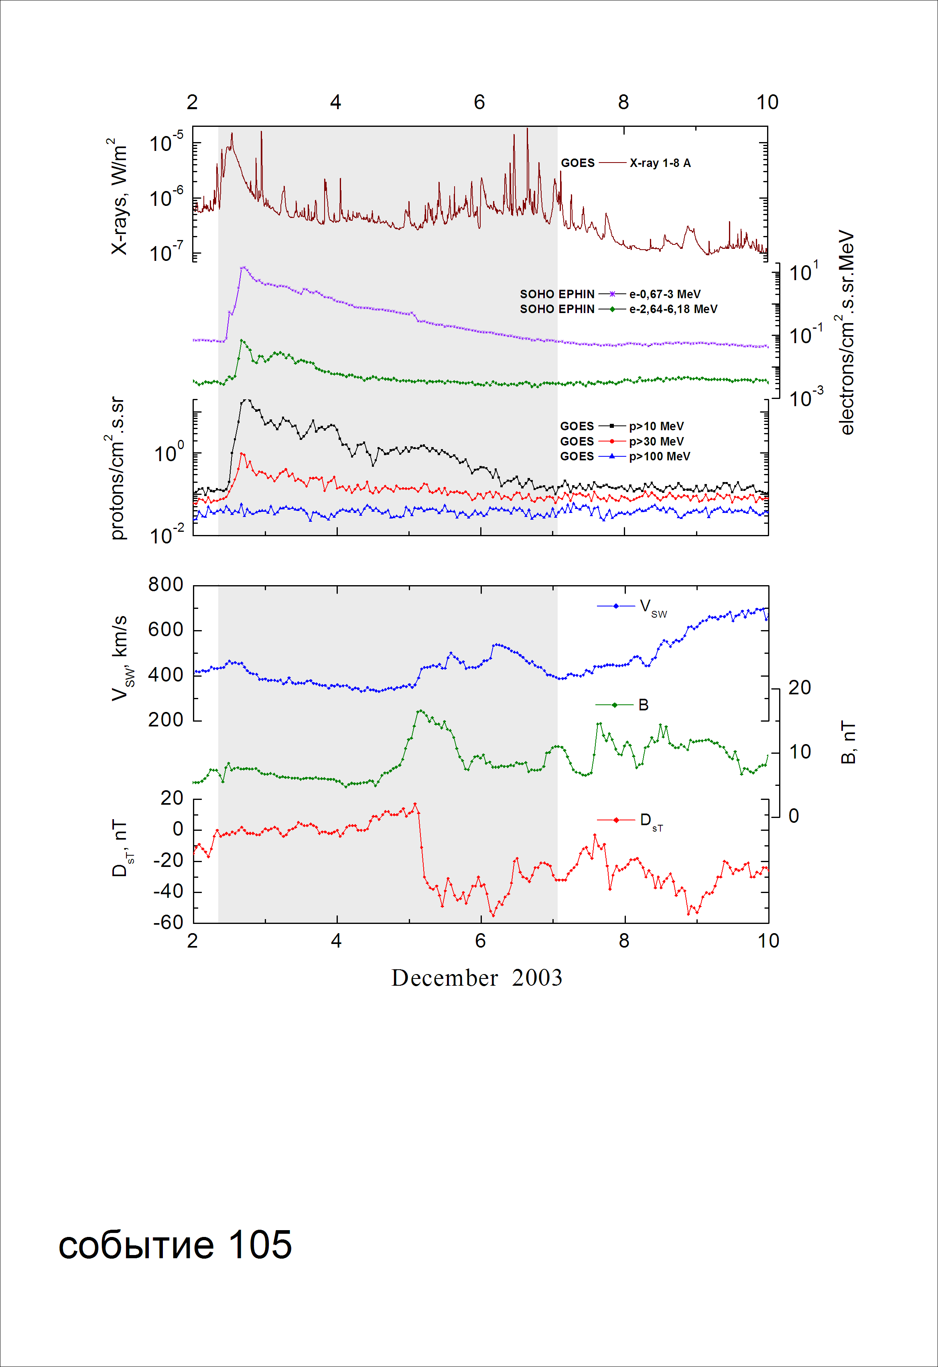
Integral time-of-maximum proton spectrum
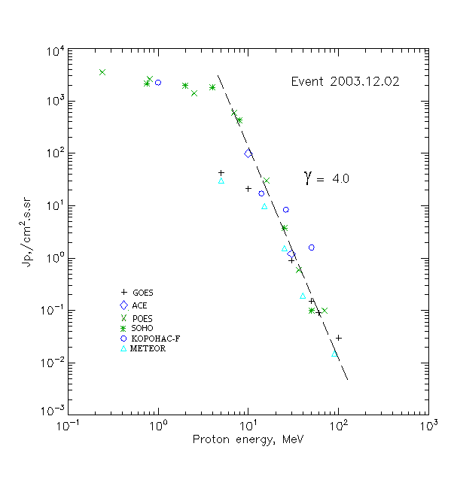

Integral fluxes of protons for the event of 2003.12.02

S/c, instruments | Eр, MeV |  | To | Tmax | Jmax,  (cm².s.sr)⁻¹ | Dura-tion | Comments
GOES-10
EPS | >5 |  | 12^{h} | 18^{h} | 42.6 | 5d
EPS | >10 |  | 12^{h} | 18^{h} | 21 | 4.5d
EPS | >30 |  | 12^{h} | 16^{h} | 0.9 | 3d
EPS | >50 |  | 10^{h} | 16^{h} | 0.15 | 2d
EPS | >60 |  | 10^{h} | 16^{h} | 0.09 | 2d
EPS | >100 |  | - | 16^{h} | 0.03 | -
METEOR
CBM | >5 | 13^{h} |  | 17^{h} | 30.4 | 3d
CBM | >10 | 13^{h} |  | 17^{h} | 9.9 | 3d
CBM | >25 | 13^{h} |  | 17^{h} | 1.56 | 1.5d
CBM | >40 | 13^{h} |  | 16^{h} | 0.19 | 1d
BP | >90 | 13^{h} |  | 15^{h} | 0.015 | 0.5d
ChD | >600 | - |  | - | - | -
POES-16
MEPED | >0.24 | - |  | 18^{h} | 3520 | 5d
MEPED | >0.8 | - |  | 17^{h} | 2610 | 5d
MEPED | >2.5 | - |  | 17^{h} | 1420 | 5d
MEPED | >6.9 | - |  | 17^{h} | 630 | 4.5d
MEPED | >16 | - |  | 17^{h} | 30 | 3d
MEPED | >36 | - |  | 17^{h} | 0.6 | 2d
MEPED | >70 | - |  | 17^{h} | 0.1 | 2d
MEPED | >140 | - |  | - | - | -
CORONAS F
MKL | >1. | - |  | 22^{h} | 2250 | 5d
MKL | >14 | - |  | 17^{h} | 17 | 4.5d
MKL | >26 | - |  | 17^{h} | 8.4 | 3d
MKL | >50 | - |  | 17^{h} | 1.6 | 2d
ACE
SIS | >10 | 12^{h} |  | 17^{h} | 98.5 | 4d
SIS | >30 | 12^{h} |  | 17^{h} | 1.2 | 3d
SOHO
EPHIN (INT) | >50 | 16^{h} |  | 17^{h} | 0.1 | 1d

Differential fluxes of protons for the event of 2003.12.02

S/c, instruments | ∆Е, MeV | To | Tmax | Jmax, (cm².s.sr.MeV)⁻¹ | Dura-tion | Comments
SOHO
LION | 0.75-2 | 12^{h} | 18^{h} | 140 | 4.5d
LION | 2-6 | 12^{h} | 18^{h} | 58 | 4.5d
EPHIN | 4-8 | 12^{h} | 17^{h} | 342 | 4d
EPHIN | 8-25 | 12^{h} | 17^{h} | 25.1 | 4d
EPHIN | 25-41 | 12^{h} | 17^{h} | 0.13 | 4d
EPHIN | 41-53 | - “ - | - “ - | - “ - | - “ -

References:
No information on publications, excepting for:
http://www.swpc.noaa.gov/ftpdir/indices/SPE.txt

