Event 2004.07.22 – (2003-204)

Particle event: To(Ep>10MeV) – 22d17^{h}
Tmax₁(Ep>10MeV) – 22d20^{h}, Jmax₁(Ep>10MeV) – 0.9 /cm².s.sr
Tmax₂(Ep>10MeV) – 23d10^{h}, Jmax₂(Ep>10MeV) – 2 /cm².s.sr
Duration of the event – 1 day
Energy of the SCR and 0.1 GCR fluxes balance – Eb(max₁) = 70 MeV
– Eb(max₂) = 155 MeV
Sources: ⊙ solar flare 22d00^{h}14^{m}, M9.1/SB, N06E25, АR10652
Main X-ray burst 1-8 Ǻ: onset – 22d00^{h}14^{m}, max – 22d00^{h}32^{m}, Ф = 0.079 J/m²
CME: 22d01^{h}32^{m}, V = 0492 km/s, Δφ = 083º, dA = 180˚
▲SC 24d06^{h}13^{m}

Particle fluxes and associated phenomena
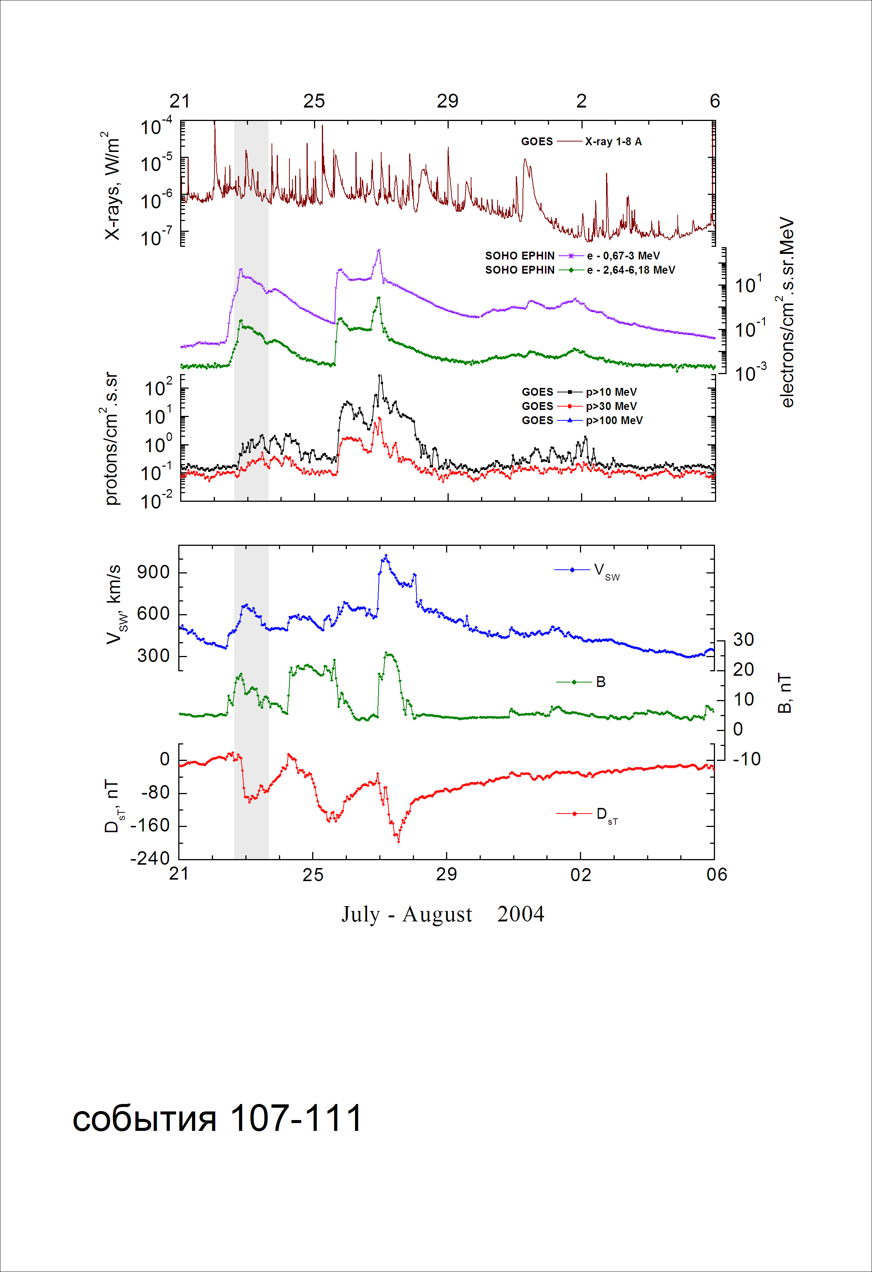
Integral time-of-maximum proton spectrum
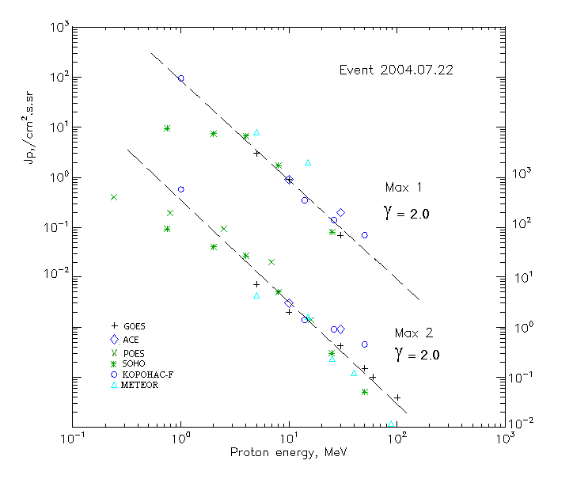

Integral fluxes of protons for the event of 2004.07.22

S/c, instruments | Eр, MeV | To | Tmax | Jmax,  (cm².s.sr)⁻¹ | Dura-tion | Comments
GOES-10
EPS | >5 | 17^{h} | 20^{h}/23d10^{h} | 3/7.1 | 1d
EPS | >10 | 17^{h} | 20^{h}/23d10^{h} | 0.9/2 | 1d
EPS | >30 | 17^{h} | 19^{h}/23d10^{h} | 0.07/0.42 | 1d
EPS | >50 | 17^{h} | - /23d10^{h} | - /0.15 | 1d
EPS | >60 | 17^{h} | - /23d10^{h} | - /0.1 | 1d
EPS | >100 | - | - /23d10^{h} | - /0.04 | -
METEOR
CBM | >5 | 11^{h} | 20^{h}/23d11^{h} | 8/4.3 | 1d
CBM | >15 | 11^{h} | 20^{h}/23d09^{h} | 2/1.6 | 1d
CBM | >25 | 22^{h} | - /23d09^{h} | - /0.23 | 1d
CBM | >40 | 22^{h} | - /23d09^{h} | - /0.12 | 1d
BP | >90 | 22^{h} | - /23d09^{h} | - /0.01 | 1d
ChD | >600 | - | - | - | -
POES-16
MEPED | >0.24 | 12^{h} | - /23d10^{h} | - /420 | 1d
MEPED | >0.8 | 12^{h} | - /23d10^{h} | - /190 | 1d
MEPED | >2.5 | 12^{h} | - /23d10^{h} | - /90 | 1d
MEPED | >6.9 | - | - /23d10^{h} | - /20 | 1d
MEPED | >16 | - | - /23d10^{h} | - /1.4 | 1d
MEPED | >36 | - | - | - | -
MEPED | >70 | - | - | - | -
MEPED | >140 | - | - | - | -
CORONAS F
MKL | >1. | - | 20^{h}/23d10^{h} | 95/560 | 1d
MKL | >14 | - | 20^{h}/23d10^{h} | 0.35/1.4 | 1d
MKL | >26 | - | 20^{h}/23d10^{h} | 0.14/0.9 | 1d
MKL | >50 | - | 20^{h}/23d10^{h} | 0.07/0.45 | 1d
ACE
SIS | >10 | 17^{h} | 19^{h}/23d08^{h} | 0.9/3 | 1d
SIS | >30 | 17^{h} | 20^{h}/23d08^{h} | 0.2/0.9 | 1d
SOHO
EPHIN (INT) | >50 | - | - /23d10^{h} | - /0.05 | 1d

Differential fluxes of protons for the event of 2004.07.22

S/c,  instruments | ∆Е, MeV | To | Tmax | Jmax, (cm².s.sr.MeV)⁻¹ | Dura-tion | Comments
SOHO
LION | 0.75-2 | 11^{h} | 20^{h}/23d08^{h} | 1.6/9.7 | 1d
LION | 2-6 | 11^{h} | 20^{h}/23d08^{h} | 0.26/1.2 | 1d
EPHIN | 4-8 | 15^{h} | 19^{h}/23d08^{h} | 1.26/2.1 | 1d
EPHIN | 8-25 | 15^{h} | 19^{h}/23d08^{h} | 0.096/0.14 | 1d
EPHIN | 25-41 | 15^{h} | 19^{h}/23d08^{h} | 0.003/0.009 | 1d
EPHIN | 41-53 | - “ - | - “ - | - “ - | - “ -

References:
No information on publications, excepting for:
http://www.swpc.noaa.gov/ftpdir/indices/SPE.txt

