Event 1998.04.20 – (1998-110)

Particle event: To(Ep>10 MeV) – 20d11^{h}
Tmax₁(Ep>10 MeV) – 21d06^{h}, Jmax₁(Ep>10 MeV) – 860 /cm².s.sr
Tmax₂(Ep>10 MeV) – 21d12^{h}, Jmax₂(Ep>10 MeV) – 1600 /cm².s.sr
Duration of the event – 7 days
Energy of the SCR and 0.1 GCR fluxes balance – Eb(max₁₎ = 440 MeV
– Eb(max₂₎ = 600 MeV

Sources: ■ solar flare 20d09^{h}38^{m}, M1.4/EP, S20W90, АR8194 ~2 days behind the W-limb.
Main burst X-ray 1-8 Ǻ: onset – 20d09^{h}38^{m}, max – 20d10^{h}21^{m}, Ф = 0.061 J/m²
CME: 20d10^{h}07^{m}, V = 1863 km/s, Δφ = 165º; dA = 284º;
ΔSC 23d18^{h}25^{m}

Particle fluxes and associated phenomena
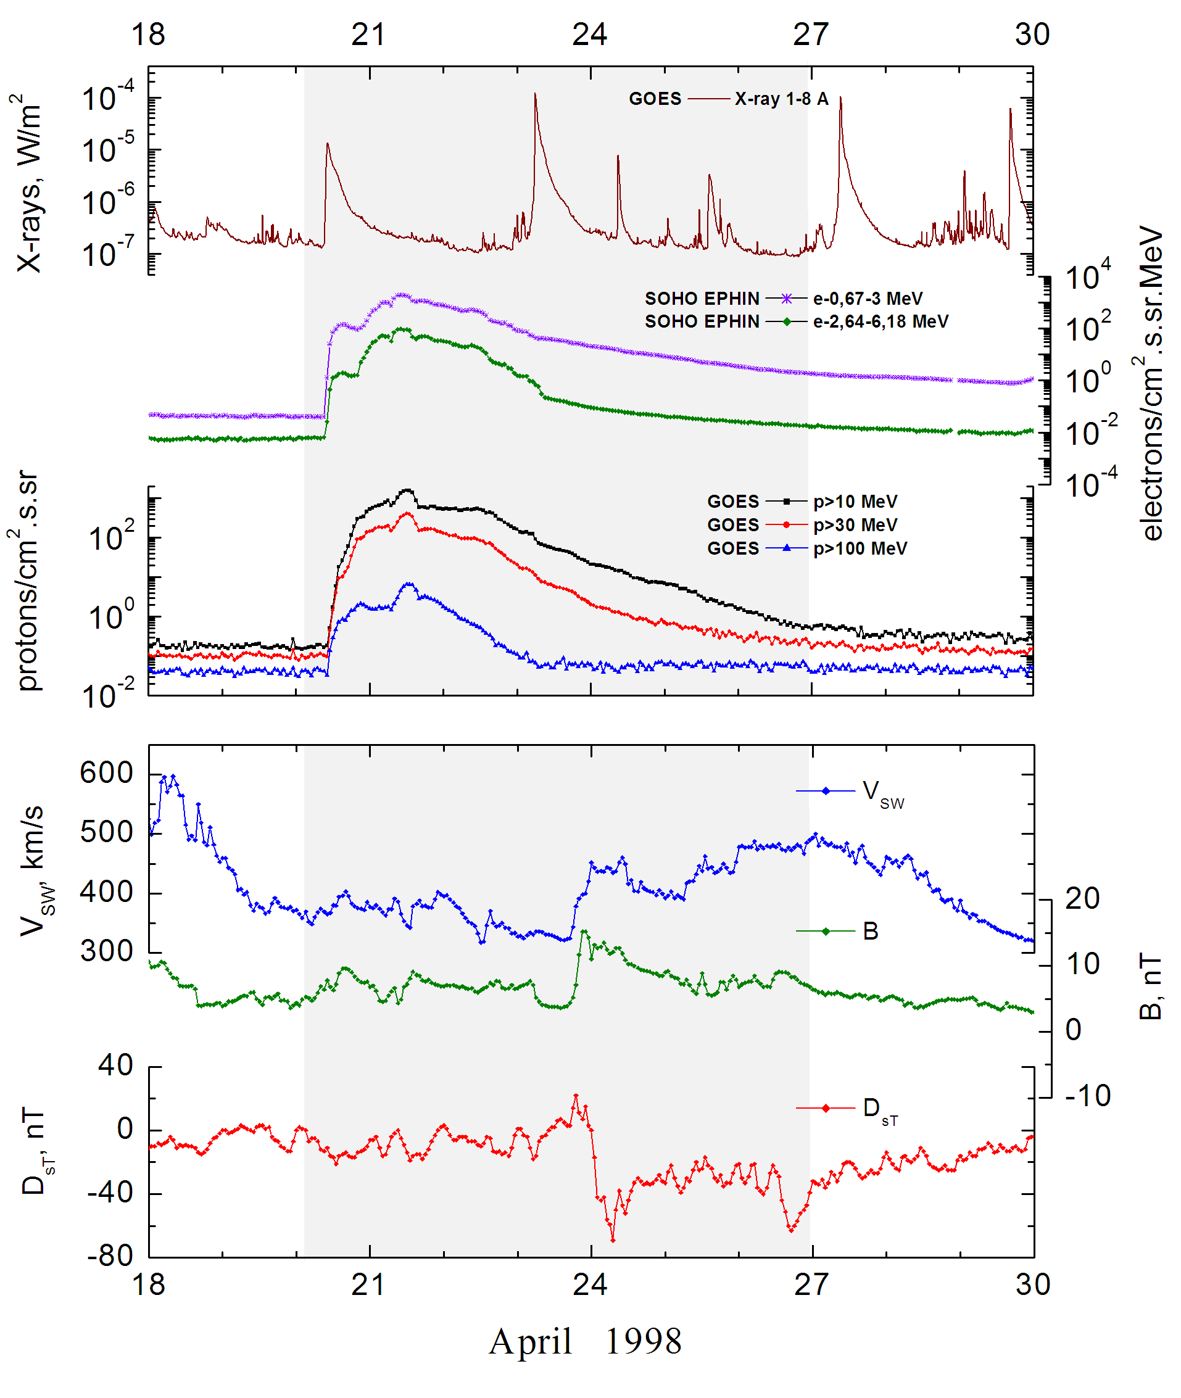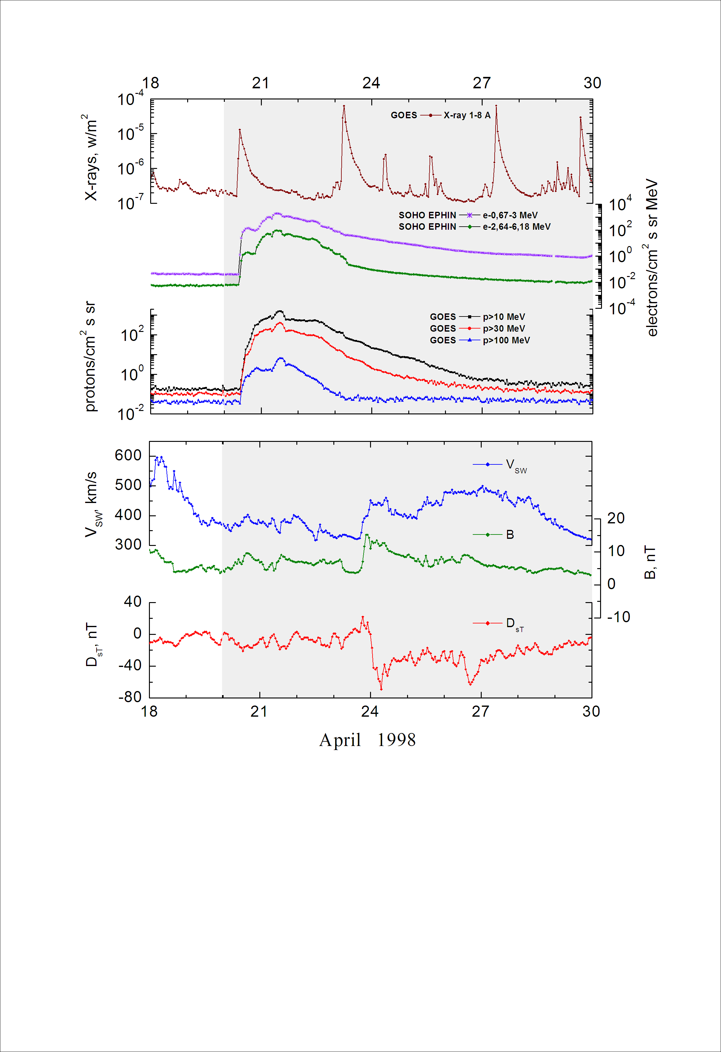

Integral time-of-maximum proton spectrum
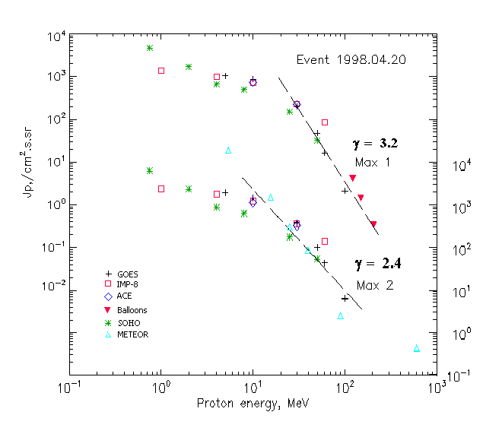

Integral fluxes of protons for the event of 1998 April 20

S/c, instruments | Eр, MeV | To | Tmax | Jmax  /cm².s.sr | Dura-tion | Comments
GOES-9
EPS | >5 | 11^{h} | 21d06^{h}/21d12^{h} | 1040/2120 | 7d
EPS | >10 | 11^{h} | 21d06^{h}/21d12^{h} | 860/1600 | 7d
EPS | >30 | 11^{h} | 21d06^{h}/21d12^{h} | 202/405 | 5d
EPS | >50 | 11^{h} | 21d06^{h}/21d12^{h} | 47/108 | 4d
EPS | >60 | 11^{h} | 21d03^{h}/21d12^{h} | 16.3/45 | 4d
EPS | >100 | 11^{h} | 21d00^{h}/21d12^{h} | 2.1/6.6 | 3d
METEOR-2
CBM | >5 | 11^{h} | - /21d14^{h} | - /19040 | 7.5d
CBM | >15 | 11^{h} | - /21d14^{h} | - /1640 | 5.5d
CBM | >25 | 11^{h} | - /21d14^{h} | - /207 | 4.2d
CBM | >40 | 11^{h} | - /21d14^{h} | - /90 | 3.4d
BP | >90 | 11^{h} | - /21d12^{h} | - /2.5 | 2.2d
ChD | >600 | - | - /21d12^{h} | - /0.43 | >6 h
IMP-8
CPME | >1 | 10^{h} | 21d06^{h}/21d13^{h} | 1360/2620 | 6d
CPME | >4 | 10^{h} | 21d06^{h}/21d13^{h} | 1000/1910 | 6d
CPME | >10 | 10^{h} | 21d06^{h}/21d13^{h} | 726/1300 | 6d
CPME | >30 | 10^{h} | 21d06^{h}/21d13^{h} | 227/375 | 5d
CPME | >60 | 10^{h} | 21d06^{h}/21d13^{h} | 86/150 | 4d
ACE
SIS | >10 | 10^{h} | 21d03^{h}/21d10^{h} | 725/1223 | 6d
SIS | >30 | 10^{h} | 21d03^{h}/21d11^{h} | 220/351 | 5d
SOHO
EPHIN (INT) | >50 | 11^{h} | 21d04^{h}/21d12^{h} | 32/56 | 3.5d
BALLOОNS
Mi | >122 |  | 21d(06^{h}-06^{h}) | 4.1
Mi | >149 |  | 21d(06^{h}-06^{h}) | 1.41
Mi | >206 |  | 21d(06^{h}-06^{h}) | 0.34

Differential fluxes of protons for the event of 998 April 20

S/c, instruments | ∆Е, MeV | To | Tmax | Jmax. /cm².s.sr.MeV | Dura  -tion | Comments
IMP-8
CPME | 1-2 | 11^{h} | 21^{h}/21d13^{h} | 144/269 | 6d
CPME | 2-4.6 | 11^{h} | 21d06^{h}/21d13^{h} | 89/203 | 6d
CPME | 4.6-15 | 11^{h} | 21d06^{h}/21d13^{h} | 33/72 | 7d
CPME | 15-25 | 11^{h} | 21d06^{h}/21d13^{h} | 33/60.6 | 7d
CPME | 25-48 | 11^{h} | 21d06^{h}/21d13^{h} | 7.5/11.5 | 7d
CPME | 48-96 | 11^{h} | 21d06^{h}/21d13^{h} | 1.1/1.9 | 7d
CPME | 96-145 | 11^{h} | 21d06^{h}/21d13^{h} | 0.9/1.71 | 7d
CPME | 145-440 | 11^{h} | 21d06^{h}/21d11^{h} | 0.09/0.125 | 7d
SOHO
LION | 0.75-2 |  | 21d05^{h}/21d11^{h} | 1670/2540 | 6d
LION | 2-6 |  | 21d04^{h}/21d11^{h} | 261/406 | 6d
EPHIN | 4-8 | 11^{h} | 21d04^{h}/21d11^{h} | 43/66 | 7d
EPHIN | 8-25 | 11^{h} | 21d04^{h}/21d11^{h} | 21/29 | 7d
EPHIN | 25-41 | 11^{h} | 21d04^{h}/21d12^{h} | 5.5/6 | 7d
EPHIN | 41-53 | - “ - | - “ - | - “ - | - “ -

References
Timofeev V.E. and S.A. Starodubtsev. The solar flare of April 20, 1998 by aboard Interball-2 measurements. – Proc. 26th Int. Cosmic Ray Conf., Salt Lake City, USA, 1999, v.6, p.196-199.
Dietrich W. and C. Lopate. Measurements of iron reach SEP events using the University of Chicago IMP-8 instrument. - Proc. 26th Int. Cosmic Ray Conf., Salt Lake City, USA, v.6, 71-74, 1999.

