Event 1998.10.18 – (1998-291)

Particle event: To(Ep>10 MeV) – 18d22^{h}
Tmax₁(Ep>10 MeV) – 19d02^{h} Jmax₁(Ep>10 MeV) – 1.8 /cm².s.sr
Tmax₂(Ep>10 MeV) – 19d06^{h} Jmax₂(Ep>10 MeV) – 2.3 /cm².s.sr
Duration of the event – 2 days
Energy of the SCR and 0.1 GCR fluxes balance – Eb(max₁) = 140 MeV
– Eb(max₂) = 80 MeV
Sources: o DSF 15d<10^{h}05^{m}, N19E10, 27º – позор, я забыл что такое DSF?
o solar flare 18d01^{h}38^{m}, M2.4/2B, N16W53, АR8358
CME: 15d10^{h}05^{m}, V = 199 km/s, Δφ = 360º, dA = 264 º
▲SC 18d19^{h}52^{m}

Particle fluxes and associated phenomena
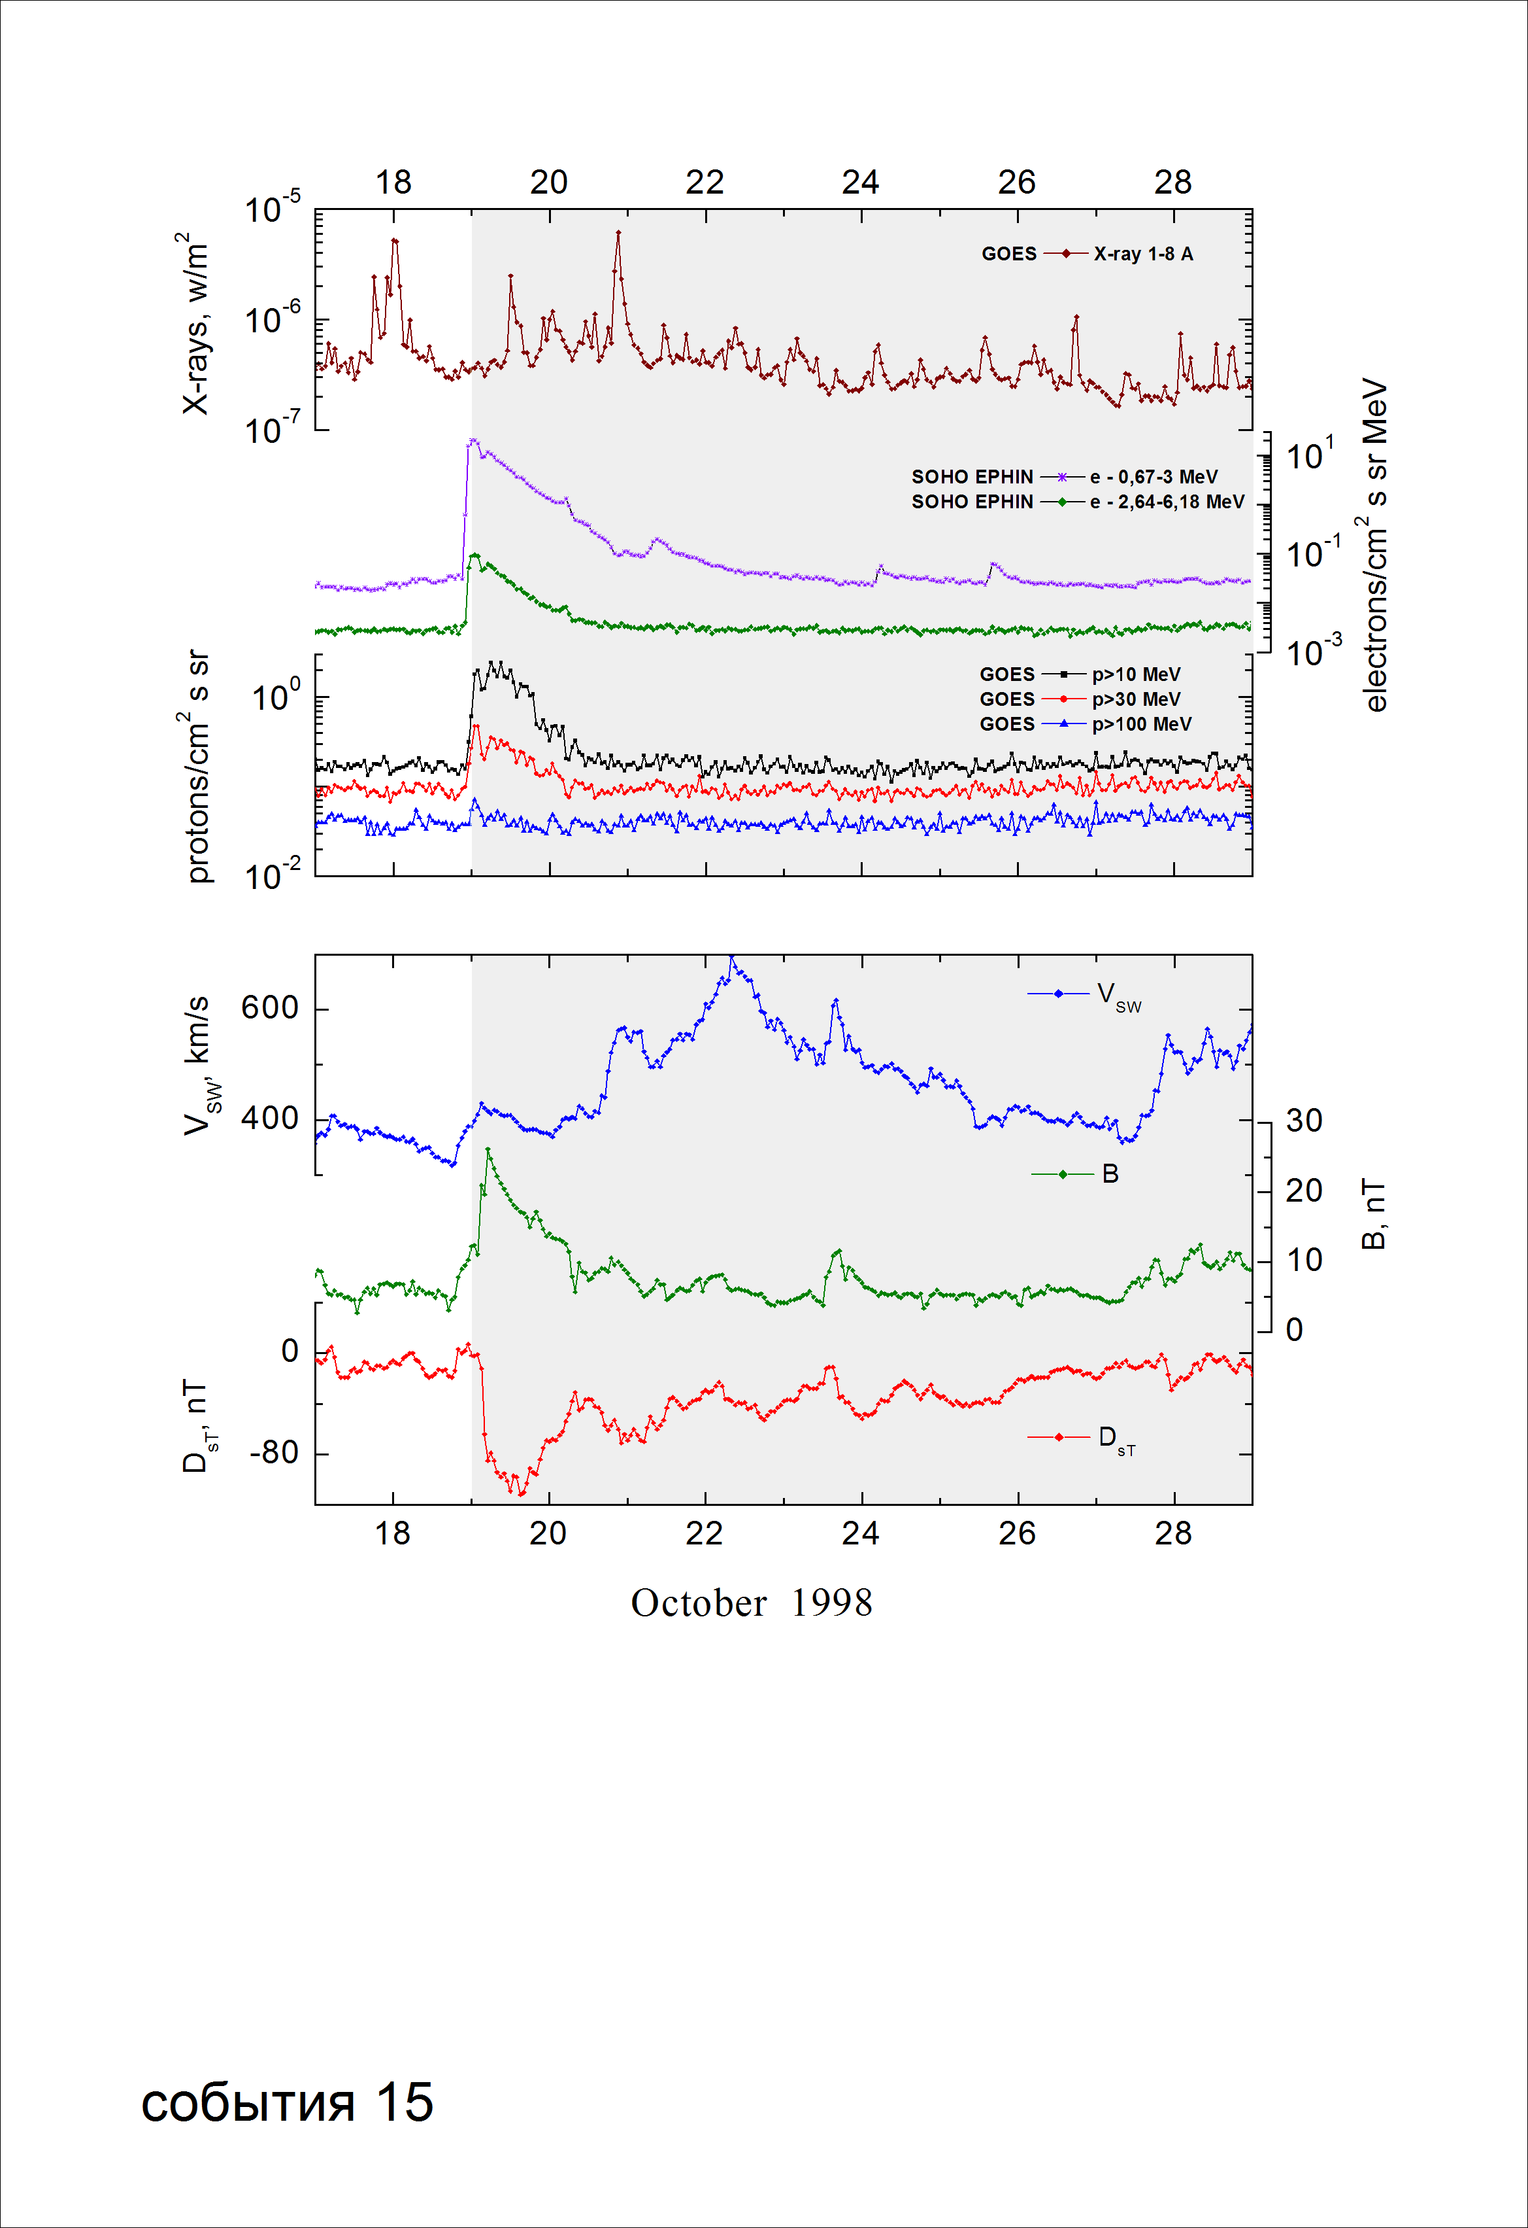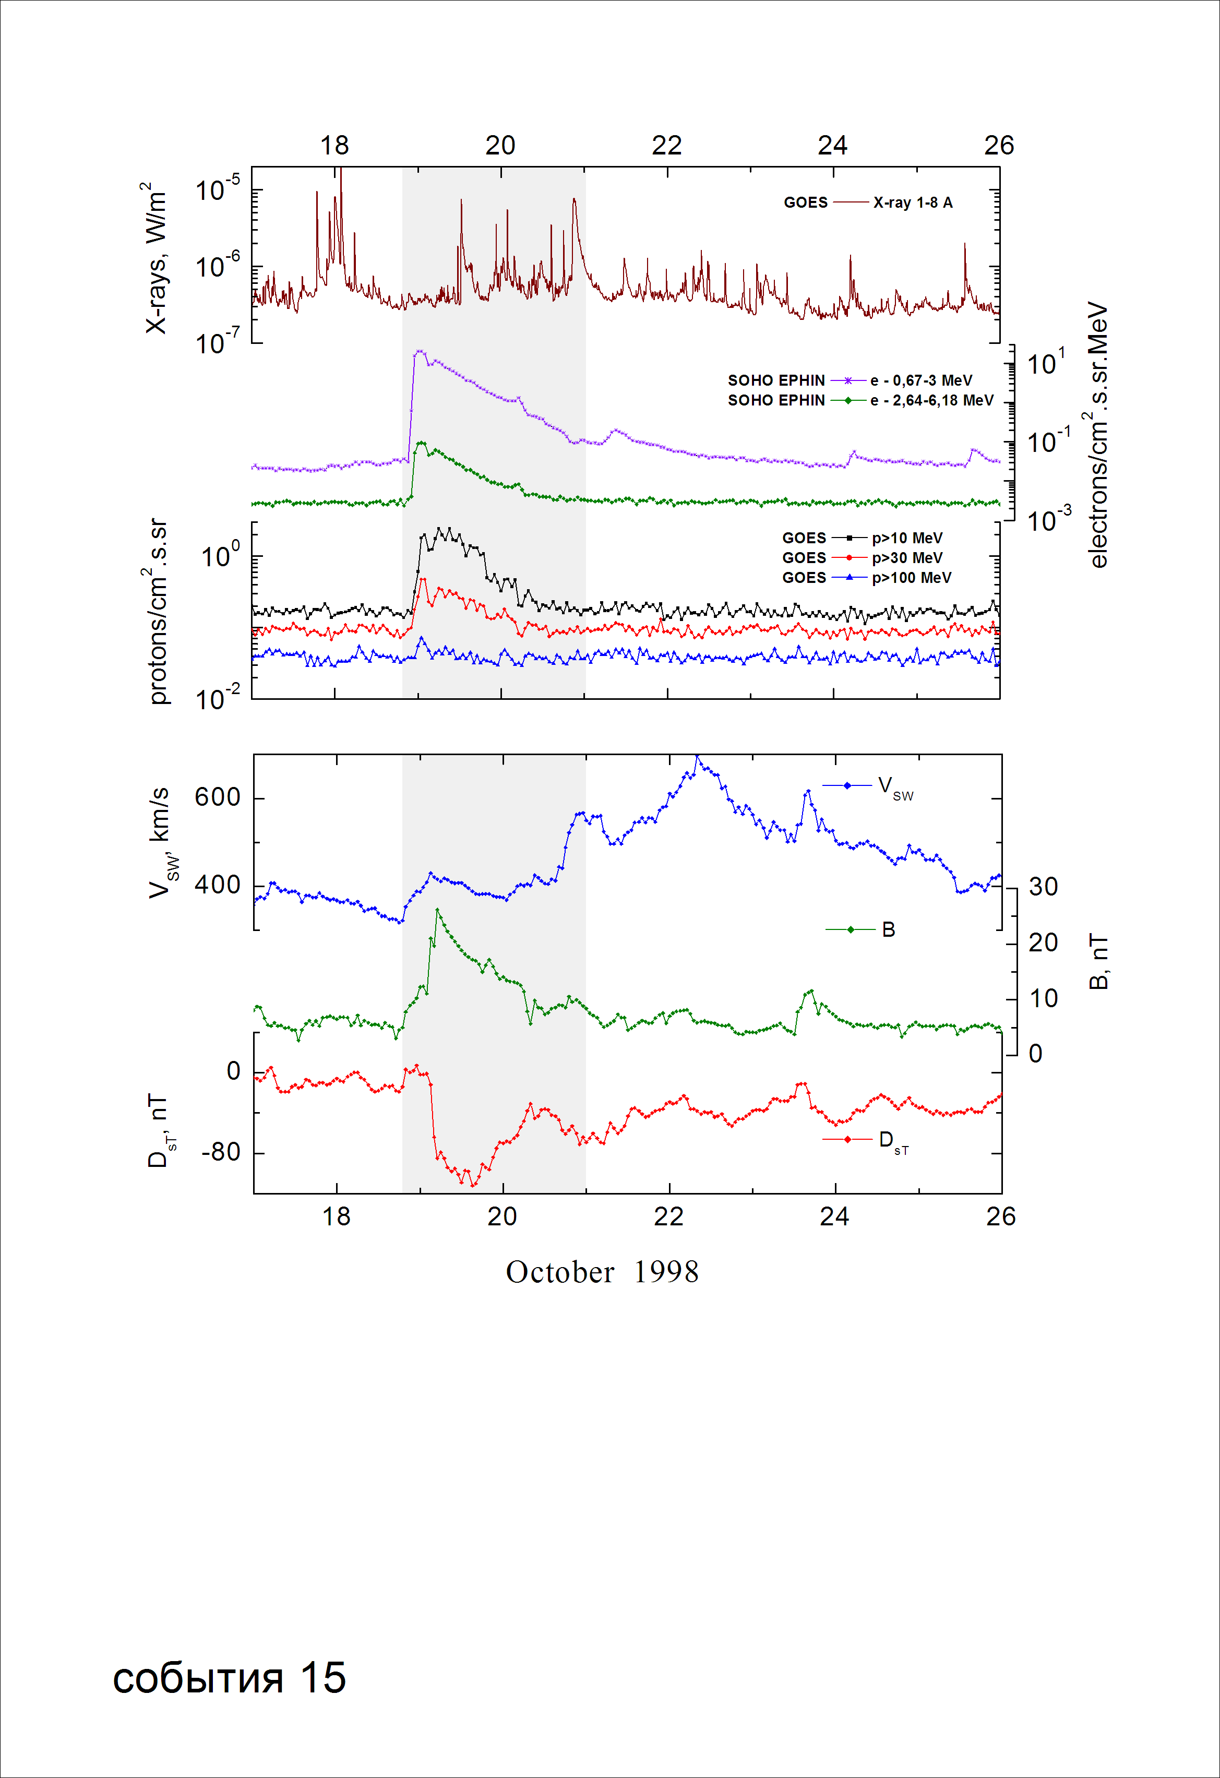
Integral time-of-maximum proton spectrum
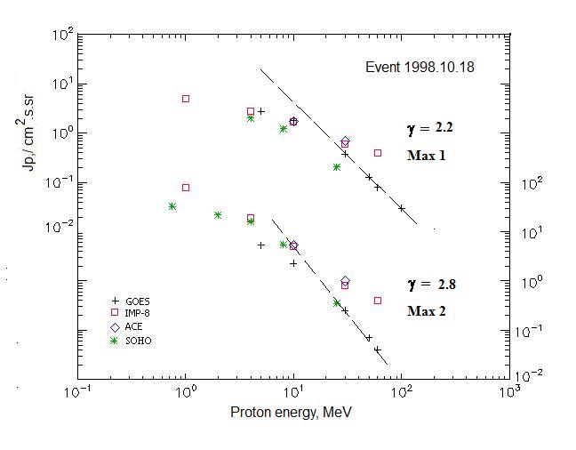

Integral fluxes of protons for the event of 1998 October 18

S/c, instrument | Eр, MeV | To | Tmax | Jmax,  /cm².s.sr | Dura-tion | Comments
GOES-10
EPS | >5 | 22^{h} | 19d02^{h}/19d09^{h} | 2.8/5.3 | 2d
EPS | >10 | 22^{h} | 19d02^{h}/19d06^{h} | 1.8/2.3 | 2d
EPS | >30 | 22^{h} | 19d02^{h}/19d06^{h} | 0.38/0.25 | 1d
EPS | >50 | 23^{h} | 19d01^{h}/19d06^{h} | 0.13/0.07 | 1d
EPS | >60 | 23^{h} | 19d01^{h}/19d06^{h} | 0.08/0.04 | 1d
EPS | >100 | 23^{h} | 19d01^{h}/ - | 0.03/ - | 1d
IMP-8
CPME | >1 | 22^{h} | 19d02^{h}/19d09^{h} | 5/77 | 2d
CPME | >4 | 22^{h} | 19d02^{h}/19d06^{h} | 2.8/18.8 | 2d
CPME | >10 | 22^{h} | 19d02^{h}/19d06^{h} | 1.7/5.1 | 2d
CPME | >30 | 22^{h} | 19d01^{h}/19d06^{h} | 0.6/0.8 | 2d
CPME | >60 | 22^{h} | 19d01^{h}/19d06^{h} | 0.4/0.4 | 2d
ACE
SIS | >10 | 22^{h} | 19d01^{h}/19d06^{h} | 1.75/5.3 | 2d
SIS | >30 | 22^{h} | 19d01^{h}/19d06^{h} | 0.7/1 | 2d
SOHO
EPHIN (INT) | >50 | - | - | - | -
Differential fluxes of protons for the event of 1998 October 18

S/c, instruments | ∆Е, MeV | To | Tmax | Jmax. /cm².s.sr.MeV | Dura-tion | Comments
IMP-8
CPME | 1-2 | 19d06^{h} | - /19d06^{h} | - /33 | ∼2d
CPME | 2-4.6 | 19d03^{h} | - /19d06^{h} | - /12 | ∼2d
CPME | 4.6-15 | 21^{h} | 19d02^{h}/19d06^{h} | 0.1/1.2 | ∼2d
CPME | 15-25 | 22^{h} | 19d02^{h}/19d06^{h} | 0.07/0.2 | ∼2d
CPME | 25-48 | 21^{h} | 19d01^{h}/19d06^{h} | 0.02/0.02 | ∼2d
CPME | 48-96 | - | - | - | -
CPME | 96-145 | - | - | - | -
CPME | 145-440 | - | - | - | -
SOHO
LION | 0,75-2 | 19d05^{h} | - /19d07^{h} | - /6.1 | 1.5d
LION | 2-6 | 19d05^{h} | - /19d07^{h} | - /1.4 | 1.5d
EPHIN | 4-8 | 23^{h} | 19d01^{h}/19d06^{h} | 0.2/2.6 | 2.5d
EPHIN | 8-25 | 22^{h} | 19d01^{h}/19d06^{h} | 0.06/0.3 | 2.5d
EPHIN | 25-41 | 22^{h} | 19d01^{h}/19d06^{h} | 0.01/0.017 | 2.5d
EPHIN | 41-53 | - “ - | - “ - | - “ - | - “ -

References
No information on publications, excepting for:
http://www.swpc.noaa.gov/ftpdir/indices/SPE.txt

