Event 1999.01.20 – (1999-020)

Particle event: To(Ep>10 MeV) – 20d23^{h}
Tmax₁(Ep>10 MeV) –21d11^{h}, Jmax₁ (Ep>10 MeV) – 1.3 /cm².s.sr
Tmax₂(Ep>10 MeV) –22d06^{h}, Jmax₂ (Ep>10 MeV) – 1 /cm².s.sr
Duration of the event – 1 day
Energy of the SCR and 0.1 GCR fluxes balance – Eb(max₁) = 270 MeV
– Eb(max₂) = 250 MeV
Sources: ▪ solar flare 20d19^{h}06^{m}, M5.2/..., N27E90, АR – unknown
Main X-ray burst 1-8 Ǻ: onset – 20d19^{h}06^{m}, max – 20d20^{h}04^{m}, Ф = 0.25 J/m²
CME: gap

Particle fluxes and associated phenomena
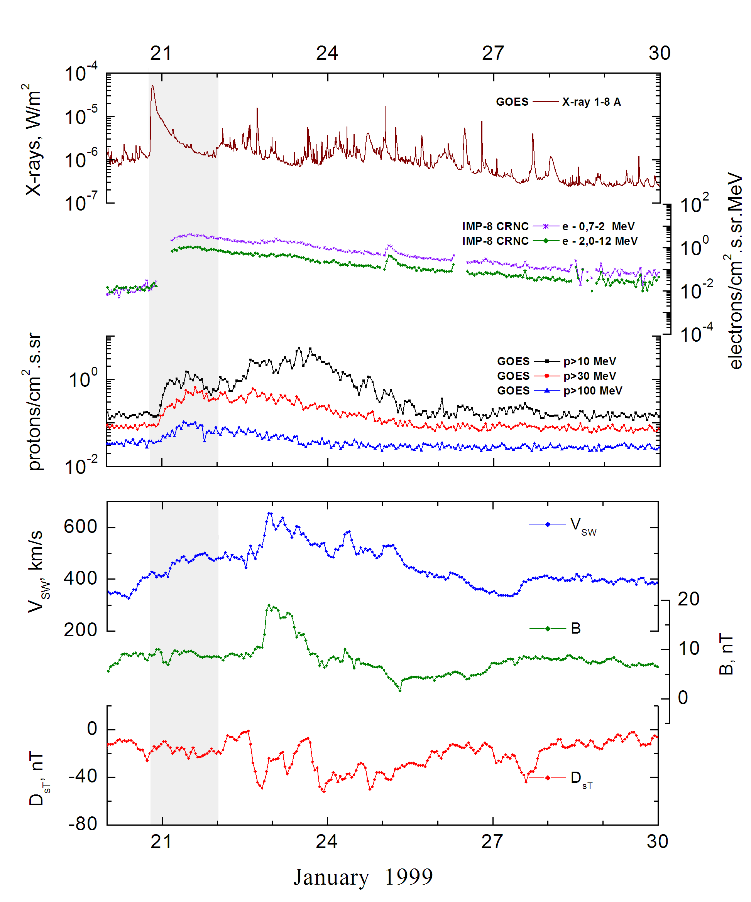
Integral time-of-maximum proton spectrum
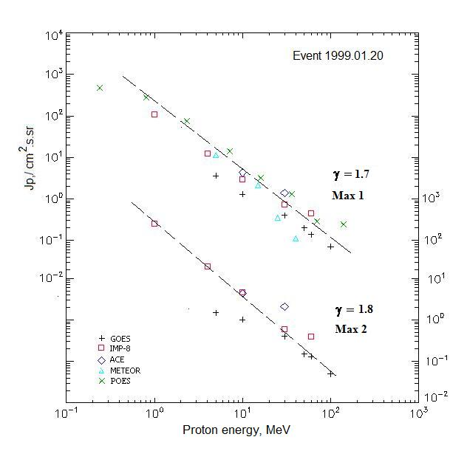

Integral fluxes of protons for the event of 1999 January 20

S/c, instruments | Eр, MeV | To | Tmax | Jmax,  /cm².s.sr | Dura-tion | Comments
GOES-10
EPS | >5 | - | 21d11^{h}/22d06^{h} | 3.6/1.5 | 1d
EPS | >10 | 23^{h} | 21d11^{h}/22d06^{h} | 1.3/1 | 1d
EPS | >30 | 23^{h} | 21d11^{h}/22d06^{h} | 0.4/0.4 | 1d
EPS | >50 | 23^{h} | 21d11^{h}/22d06^{h} | 0.2/0.15 | 1d
EPS | >60 | 23^{h} | 21d11^{h}/22d06^{h} | 0.14/0.13 | 1d
EPS | >100 | 23^{h} | 21d11^{h}/22d06^{h} | 0.07/0.05 | 1d
METEOR-2
CBM | >5 | 22^{h} | 21d17^{h}/ - | 11,6/ - | 1.5d
CBM | >15 | 22^{h} | 21d15^{h}/ - | 2,15/ - | 1.5d
CBM | >25 | 22^{h} | 21d14^{h}/ - | 0,35/ - | 1.5d
CBM | >40 | 22^{h} | 21d13^{h}/ - | 0,11/ - | 1.5d
POES-15
MEPED | >0.24 | - | 21d18^{h}/ - | 460/ - | -
MEPED | >0.8 | - | 21d18^{h}/ - | 270/ - | -
MEPED | >2.5 | - | 21d18^{h}/ - | 82/ - | -
MEPED | >6.9 | - | 21d18^{h}/ - | 13/ - | -
MEPED | >16 | - | 21d18^{h}/ - | 3.16/ - | -
MEPED | >36 | - | 21d18^{h}/ - | 1.3/ - | -
MEPED | >70 | - | 21d18^{h}/ - | 0.29/ - | -
MEPED | >140 | - | 21d18^{h}/ - | 0.24/ - | -
IMP-8
CPME | >1 | 17^{h} | 21d15^{h}/22d06^{h} | 110/205 | 1d
CPME | >4 | <21d04^{h} | 21d12^{h}/22d06^{h} | 12.4/19.6 | 1d
CPME | >10 | <21d04^{h} | 21d15^{h}/22d06^{h} | 3/4.7 | 1d
CPME | >30 | <21d04^{h} | 21d15^{h}/22d06^{h} | 0.75/0.6 | 1d
CPME | >60 | <21d04^{h} | 21d15^{h}/22d06^{h} | 0.45/0.4 | 1d
ACE
SIS | >10 | 23^{h} | 21d14^{h}/22d06^{h} | 4.3/4.4 | 1d
SIS | >30 | 23^{h} | 21d14^{h}/22d06^{h} | 1.4/ 2,1 | 1d

Differential fluxes of protons for the event of 1999 January 20

S/c, instruments | ∆Е, MeV | To | Tmax | Jmax  /cm².s.sr.MeV | Dura-tion | Comments
IMP-8
CPME | 1-2 | 07^{h} | 21d15^{h}/22d04^{h} | 72/124 | 1d
CPME | 2-4.6 | 08^{h} | 21d15^{h}/22d04^{h} | 13/23 | 1d
CPME | 4.6-15 | <21d04^{h} | 21d12^{h}/22d04^{h} | 0.7/1.2 | 1d
CPME | 15-25 | <21d04^{h} | 21d12^{h}/22d04^{h} | 0.07/0.12 | 1d
CPME | 25-48 | <21d04^{h} | 21d18^{h}/22d04^{h} | 0.0180/02 | 1d
CPME | 48-96 | <21d04^{h} | 21d15^{h}/22d04^{h} | 0.005/0.004 | 1d
CPME | 96-145 | <21d04^{h} | 21d18^{h}/22d03^{h} | 0.0025/0.004 | 1d
CPME | 145-440 | <21d04^{h} | 21d12^{h}/22d03^{h} | 0.001/0.0006 | 1d
SOHO |  | Data | absent

References
No information on publications, excepting for:
http://www.swpc.noaa.gov/ftpdir/indices/SPE.txt

